ANGULAR AND ASP.NET CORE WEB API

Contents

Important Links 3

Course structure 3

Angular project setup and version history 4

Setting up the development environment 5

Create a new Angular application 6

Running the application 7

Working with VS Code 8

Opening the newly created project in VS Code 8

What has changed in Angular 9 ? 9

Ivy 9

Breaking changes in Angular 9 13

Folder structure and flow of angular application 14

Angular Component 15

Important angular extensions and multiple ways to create components 19

Developing a sample application in Angular 9 21

Creating a homepage for our application 21

Adding a property card component manually 21

Adding a property list component using CLI 24

Adding a component from VSCode environment 26

Development hands-on for Property Application 27

Adding Bootstrap and learning more on Typescript 27

Installing Bootstrap into your frontend application 29

Setting up the HTML for the property application 30

Adding some properties to PropertyCard Component 31

Configuring GITHUB 32

Hands-on (Update Property list component) 33

Hands-On : Add CSS Animation to Property Card 35

Adding buttons on image with CSS effects 36

Adding glyph icons instead of buttons 38

Using Service and HTTP Calls in Angular 9 38

Angular Services 40

Creating a service and fetch the property data 40

Modify HTTP Data using Pipe 43

Understanding Routing Part-1 45

Enable Routing in the application 46

How to configure the routing to load the components dynamically from the index page? 46

Routing Part 2 48

How to make the selected menu active only and rest of the menu’s disabled 49

Adding a new Property Detail Component 50

How to pass the ID of the property to the property-details page 51

How to fetch the parameter passed to the route in any component 52

How to use Router Service to achieve the navigation using event binding 53

Routing with Angular Part-3 54

How to pass the value to the same component ? 54

How to navigate in the same component through RouterLink 55

How to render a page not found component 56

How to render images of property from the model instead of hardcoded image 57

Rendering the list of properties by passing a value of type sell or rent and map it to the Rent or Sell page 58

Template Driven forms in Angular 60

Disable the save button by adding attribute 63

Add the red border on textbox through Angular based classes 63

How to show the warning message based on control valid state 63

How to get the reference of the ngForm in the component code 64

Add the min-length validation along with other validations 64

Reactive Forms in Angular 65

How to add global level CSS 70

Benefits of using reactive forms 70

Usage of FormBuilder 70

Save data to local storage in Angular 72

Adding the user operations to a user service 72

Validating the form on Submit 74

Working with models 74

Adding client-side alert notifications and dialogs 76

Login / Logout features hands-on 80

Adding more menus to the home screen in nav bar 82

Add new property listing – Hands ON 83

# Important Links

<https://github.com/webtrainer-in/HSPA>

https://www.whizlabs.com/blog/azure-certifications-path/

https://www.qfles.com/interview-question

<https://www.youtube.com/watch?v=xKsdnnOXvAs&list=PL_NVFNExoAxclqXo9fLAeP0G2Qp56Fu8C&index=1>

<https://yeoman.io/generators/>

https://www.npmjs.com/package/generator-aspnet-core

<https://codewithmukesh.com/project/aspnet-core-hero-boilerplate/>

<https://codewithmukesh.com/project/aspnet-core-webapi-clean-architecture%e2%80%8b/>

<https://www.qfles.com/interview-question/solid-principles-interview-questions>

https://restfulapi.net/versioning/

[**https://developers.google.com/speed/pagespeed/insights/**](https://developers.google.com/speed/pagespeed/insights/)

[**https://testmysite.withgoogle.com/intl/en-gb**](https://testmysite.withgoogle.com/intl/en-gb)

https://www.algoexpert.io/product

<https://www.bezkoder.com/angular-10-refresh-token/>

<https://michaelscodingspot.com/find-fix-and-avoid-memory-leaks-in-c-net-8-best-practices/>

https://michaelscodingspot.com/5-techniques-to-avoid-memory-leaks-by-events-in-c-net-you-should-know/

<https://docs.microsoft.com/en-us/dotnet/architecture/microservices/architect-microservice-container-applications/communication-in-microservice-architecture>

https://www.c-sharpcorner.com/UploadFile/bd5be5/design-patterns-in-net/

<https://kumarashwinhubert.com/10-exception-handling-best-practices-in-csharp>

https://www.c-sharpcorner.com/UploadFile/1492b1/restful-day-sharp5-security-in-web-apis-basic-authentication-a/

## Azure Imp Links

**Load Balancer** : <https://docs.microsoft.com/en-us/azure/load-balancer/load-balancer-overview>

# Course structure

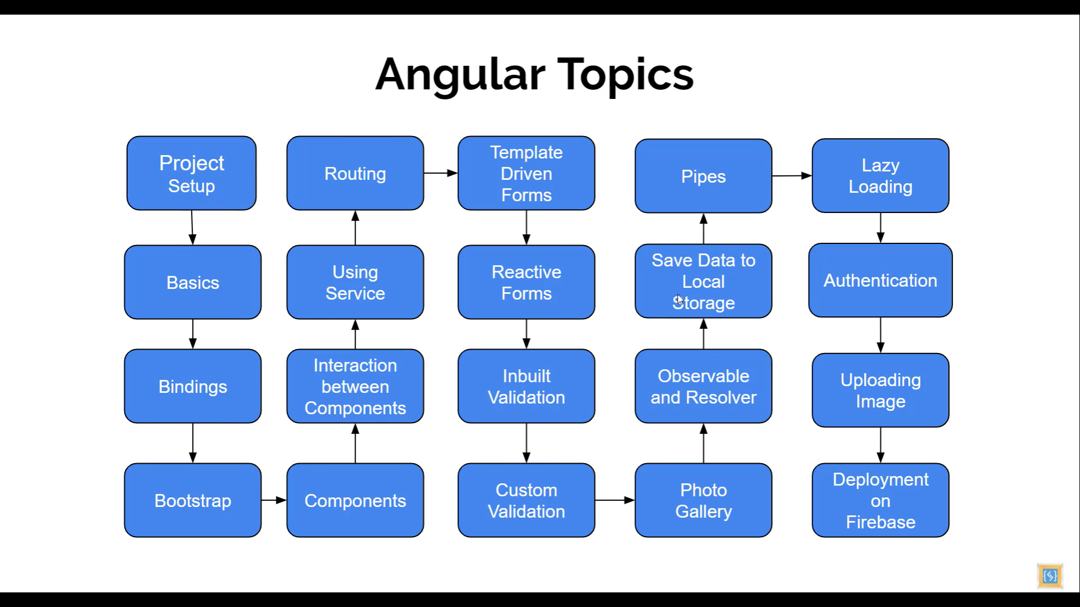

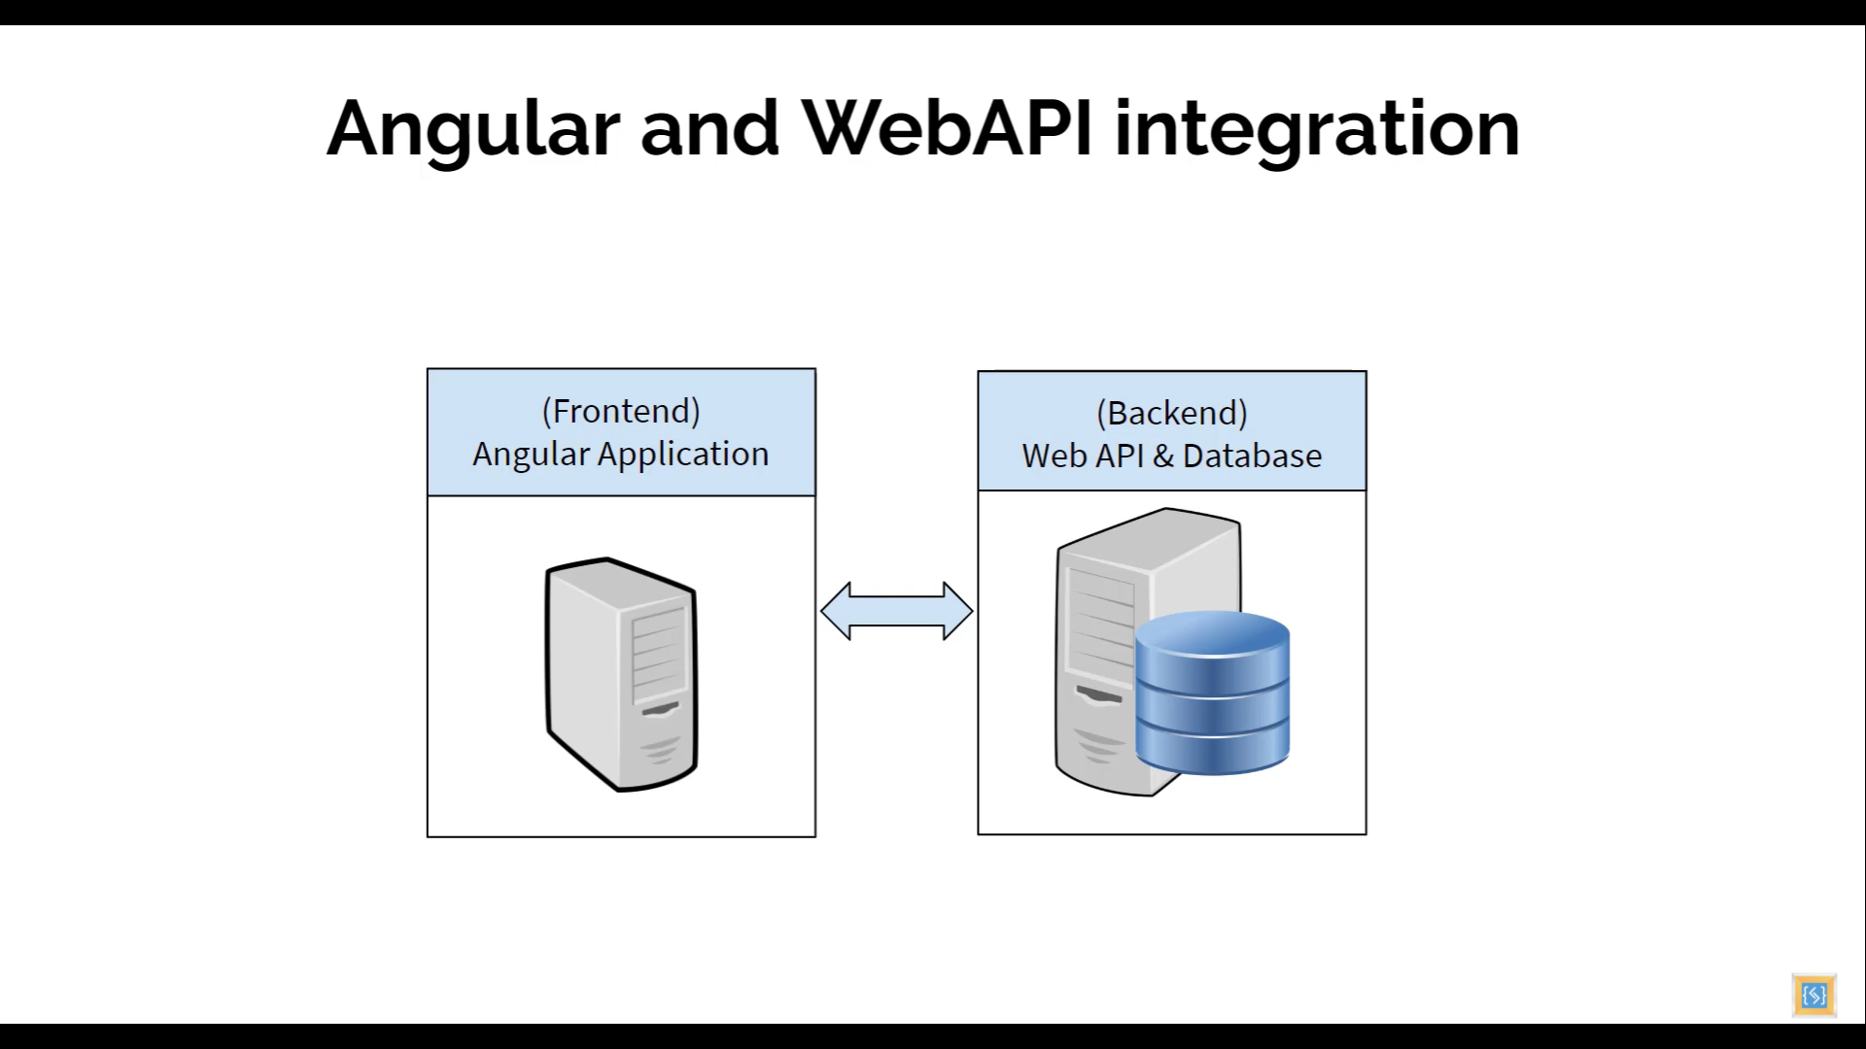

# Angular project setup and version history

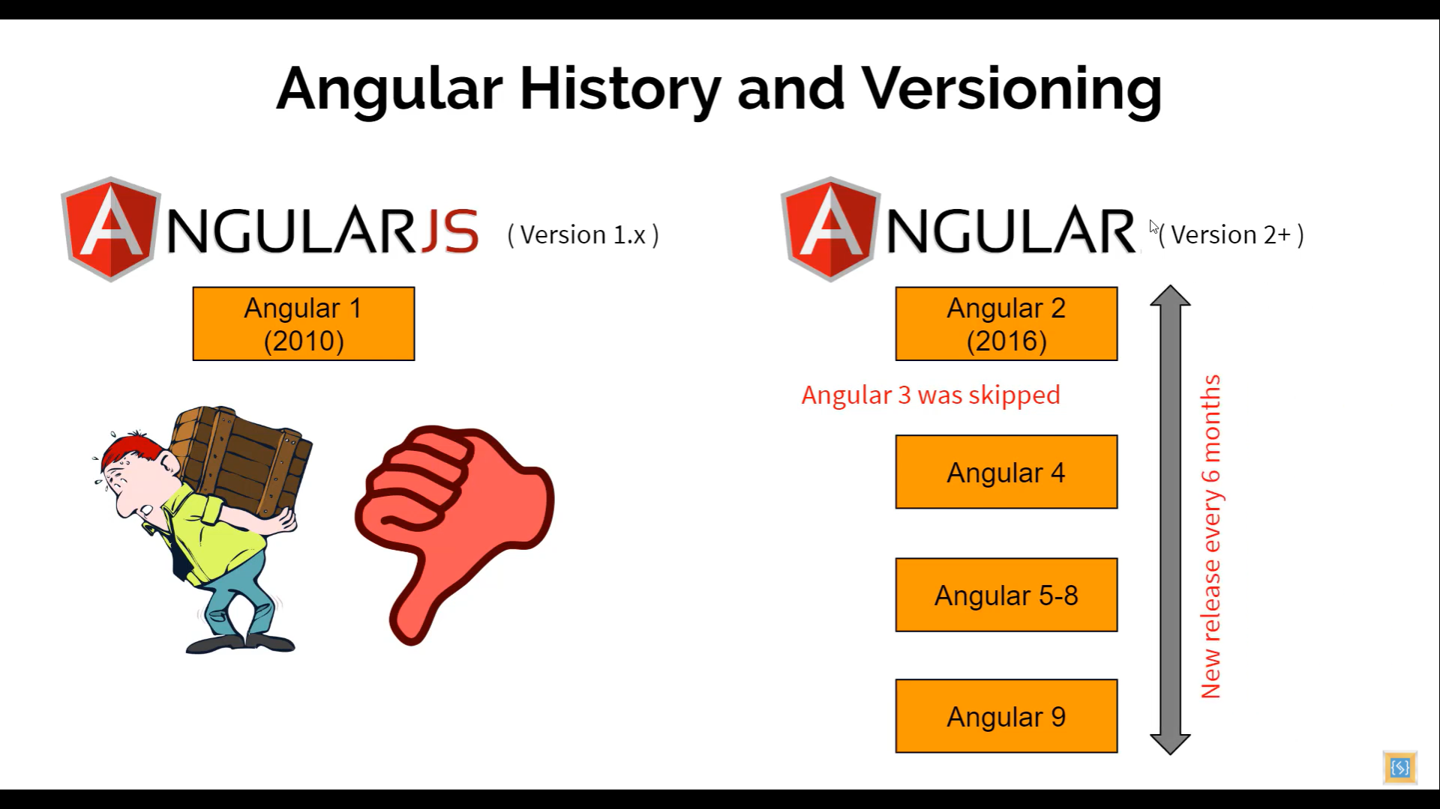

## Setting up the development environment

**Installing NPM**

Navigate to nodejs.org/en

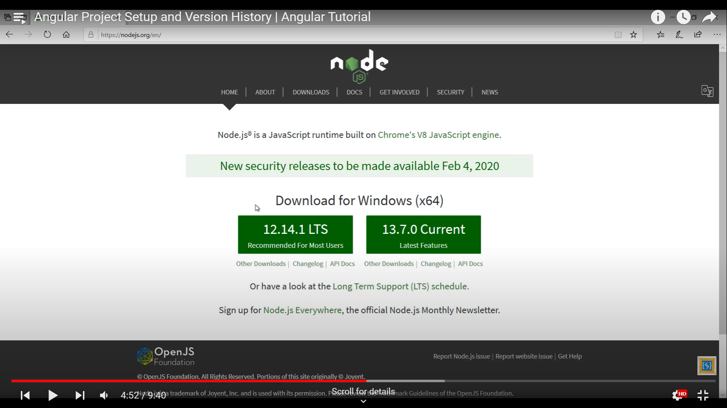

**Installing Angular CLI**

Navigate to cli.angular.io

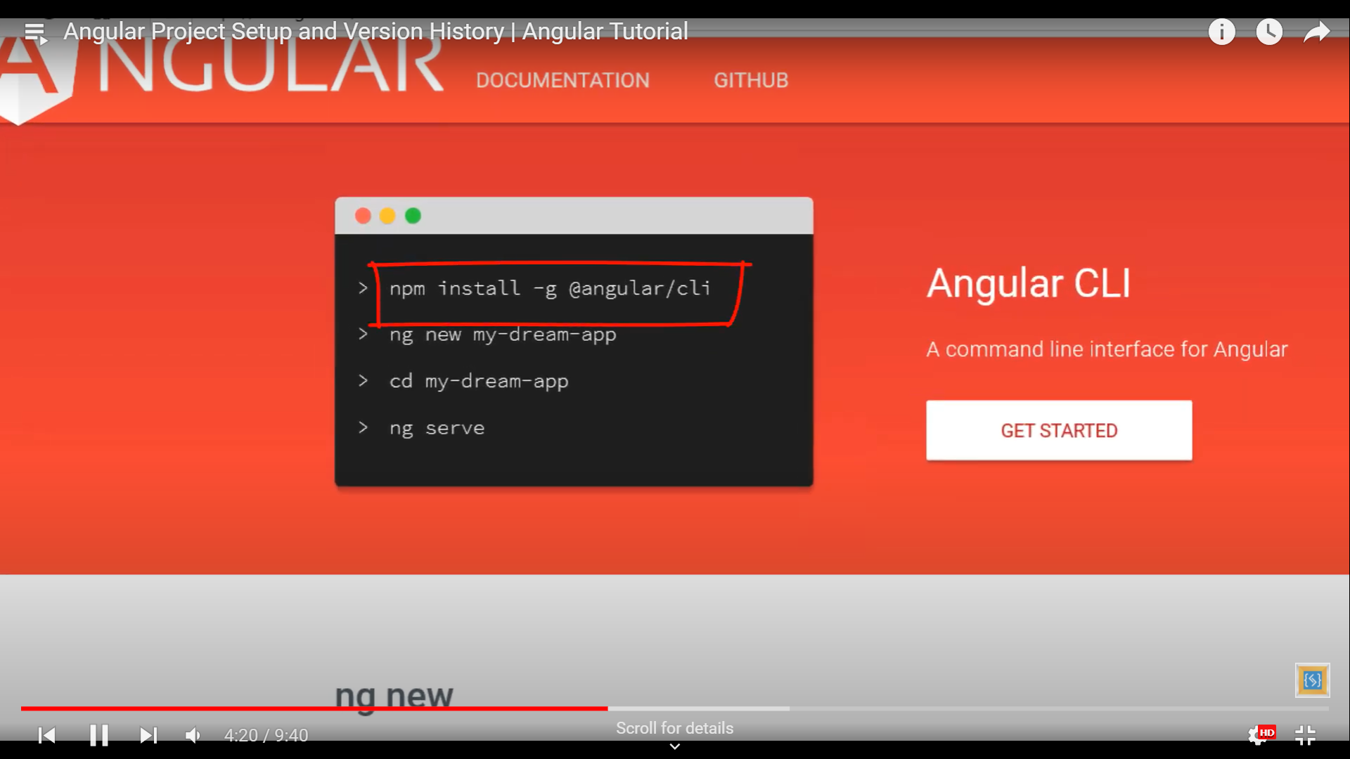

Commands to install the Angular CLI

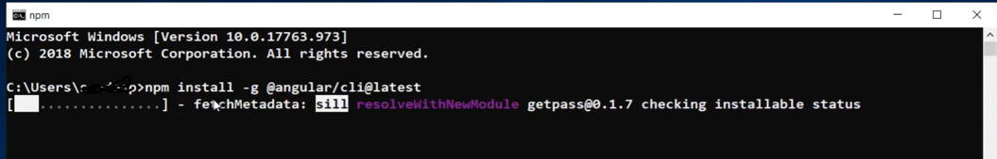

To check the version installed run the command >ng –version

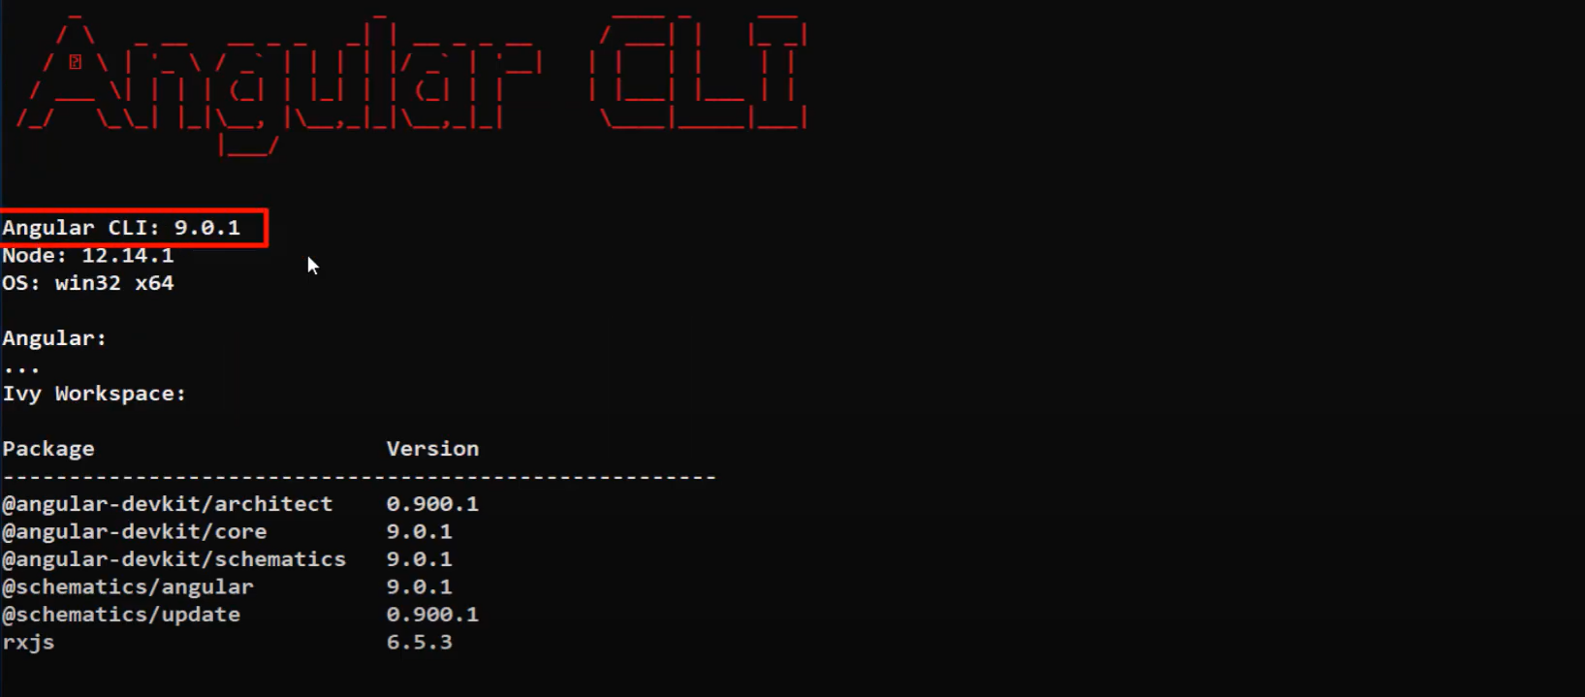

## Create a new Angular application

1. Navigate to a folder in CMD where you want to create the angular app
2. Type command >ng new my-first-ng-app
3. During app creation it will ask the question to add “Angular Routing” enter n
4. It will ask for the stylesheet format to use
   1. Press enter to use default

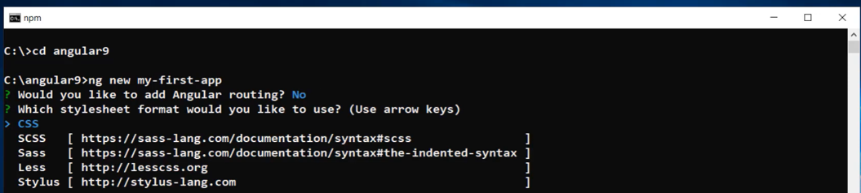

## Running the application

1. Navigate to the directory where you created the app
2. Type command >ng serve

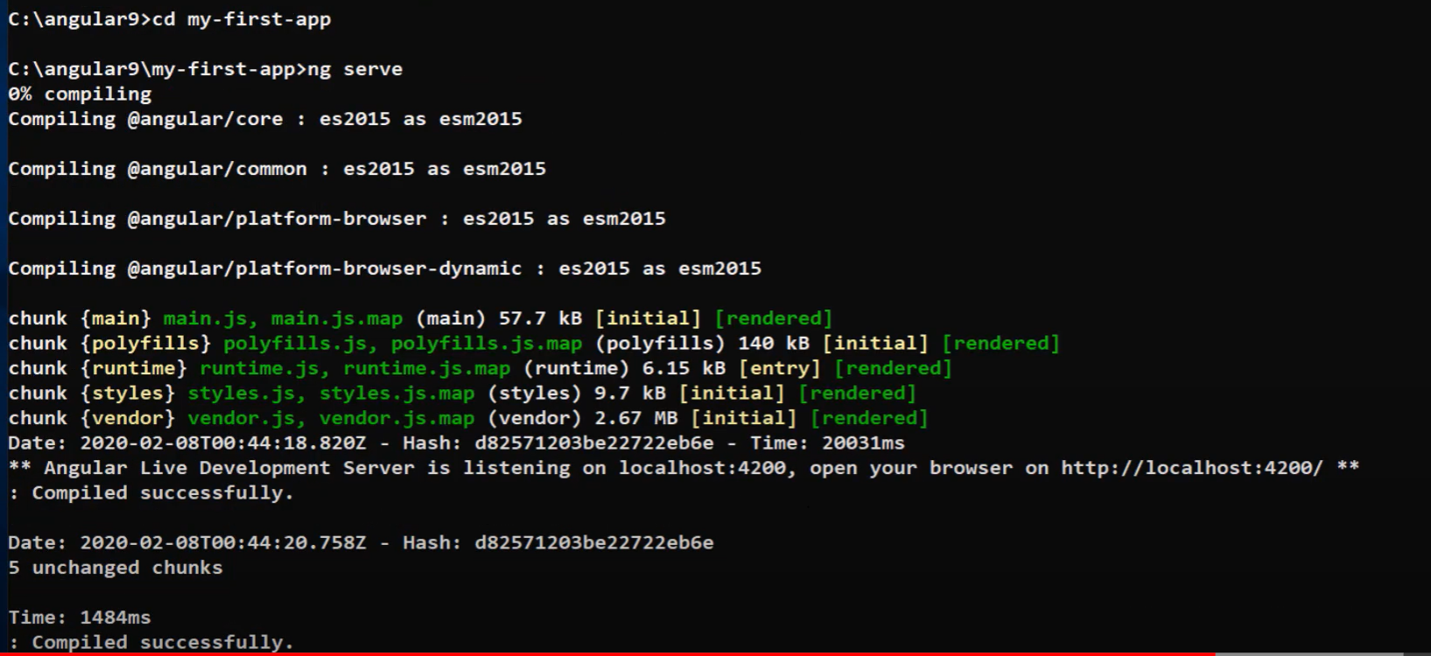

1. Type the port of localhost on which the development server started listening as below

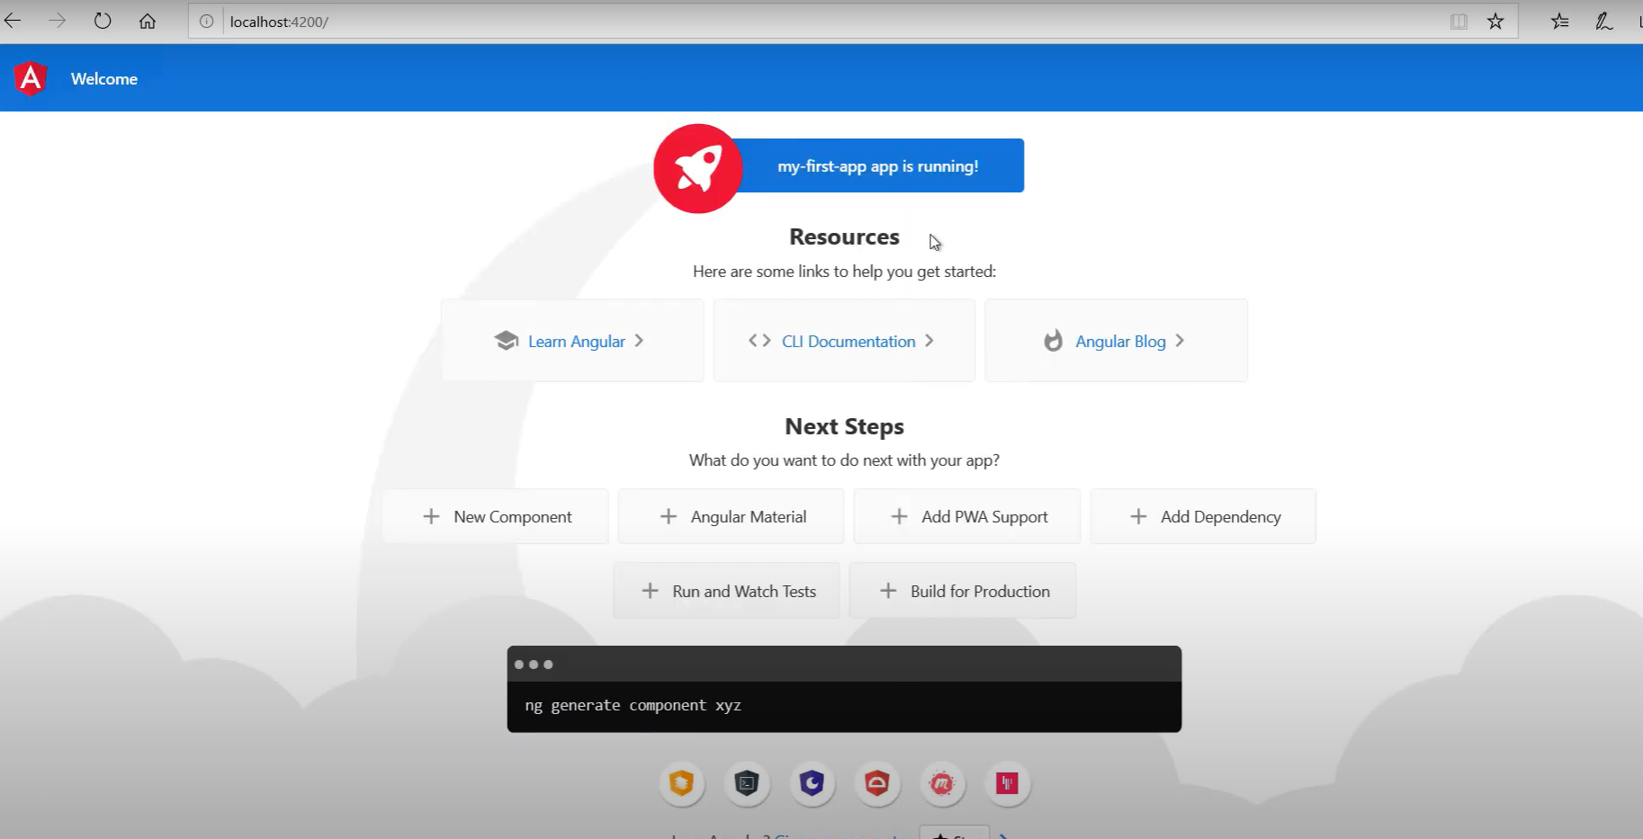

1. Press ctrl+c to stop the server

# Working with VS Code

To install it on your machine navigate to code.visualstudio.com which is free editor

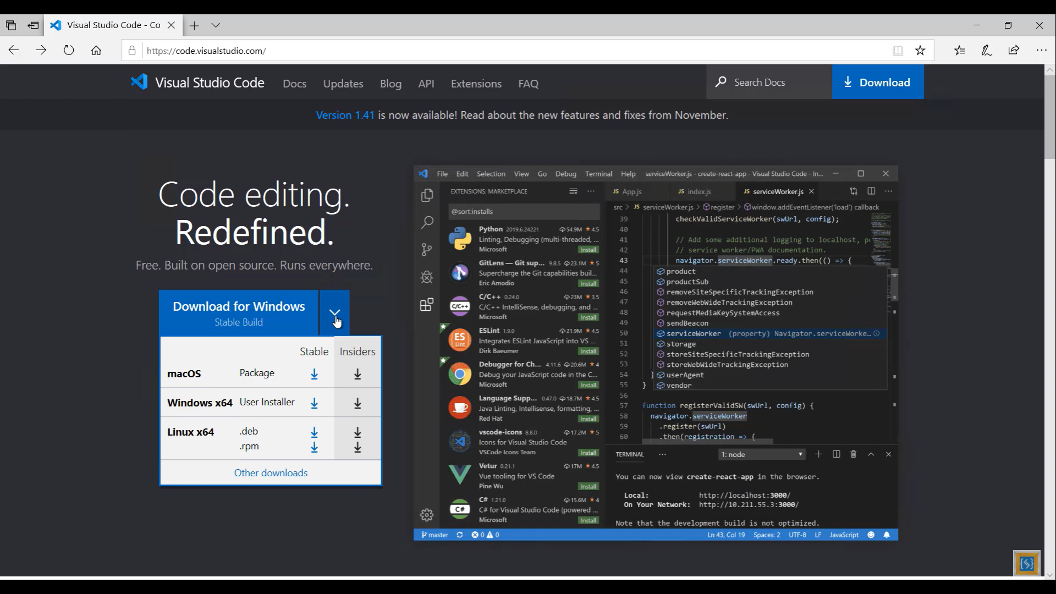

## Opening the newly created project in VS Code

1. Open VS Code
2. File -> Open Folder

OR type these commands

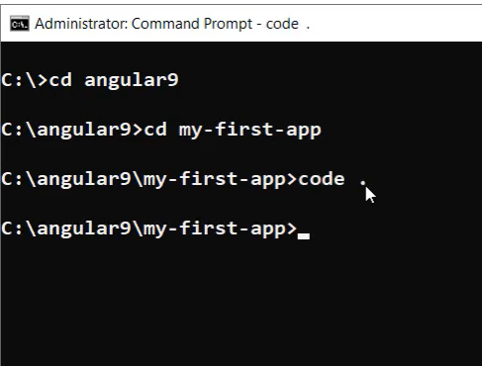

# What has changed in Angular 9 ?

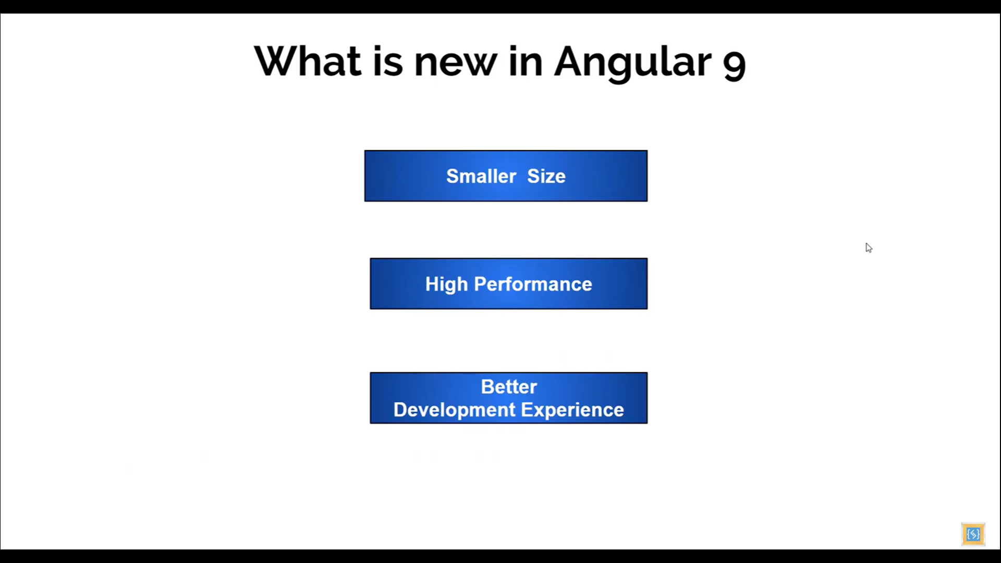

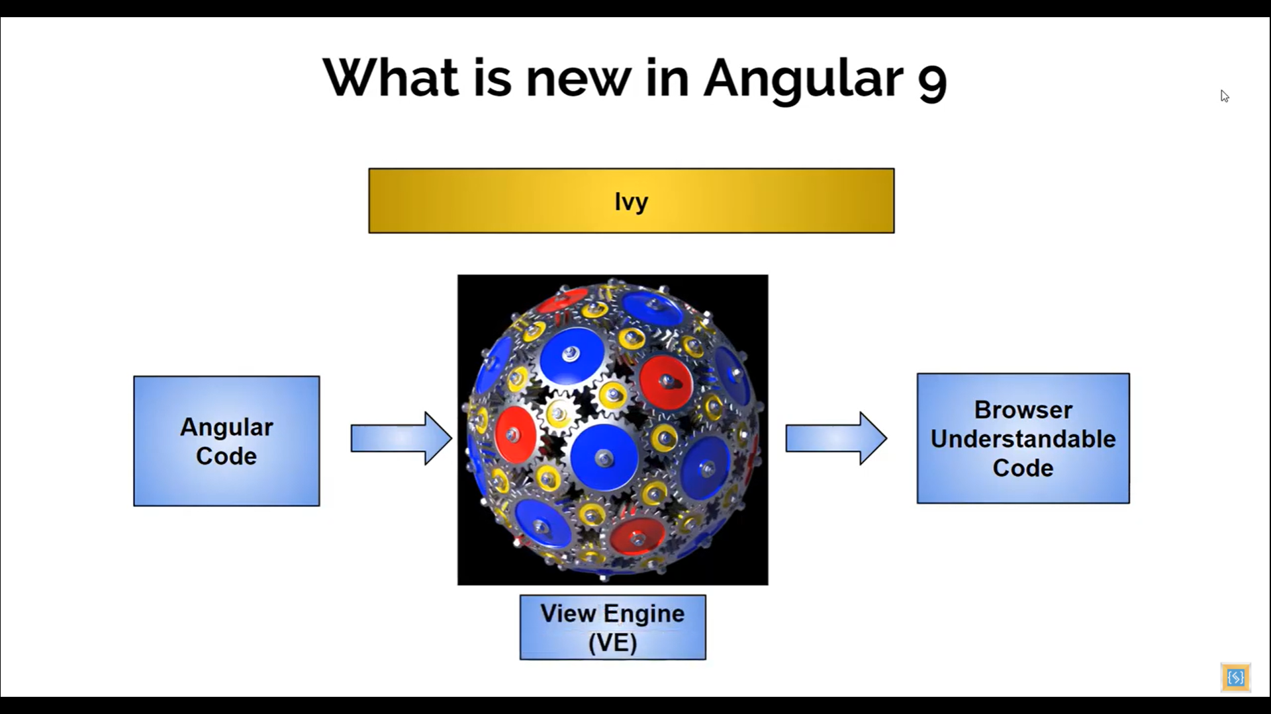

Ivy

1. New code name for the compiler
2. Converts angular code to browser compatible code
3. Default in Angular 9 and can be disabled too

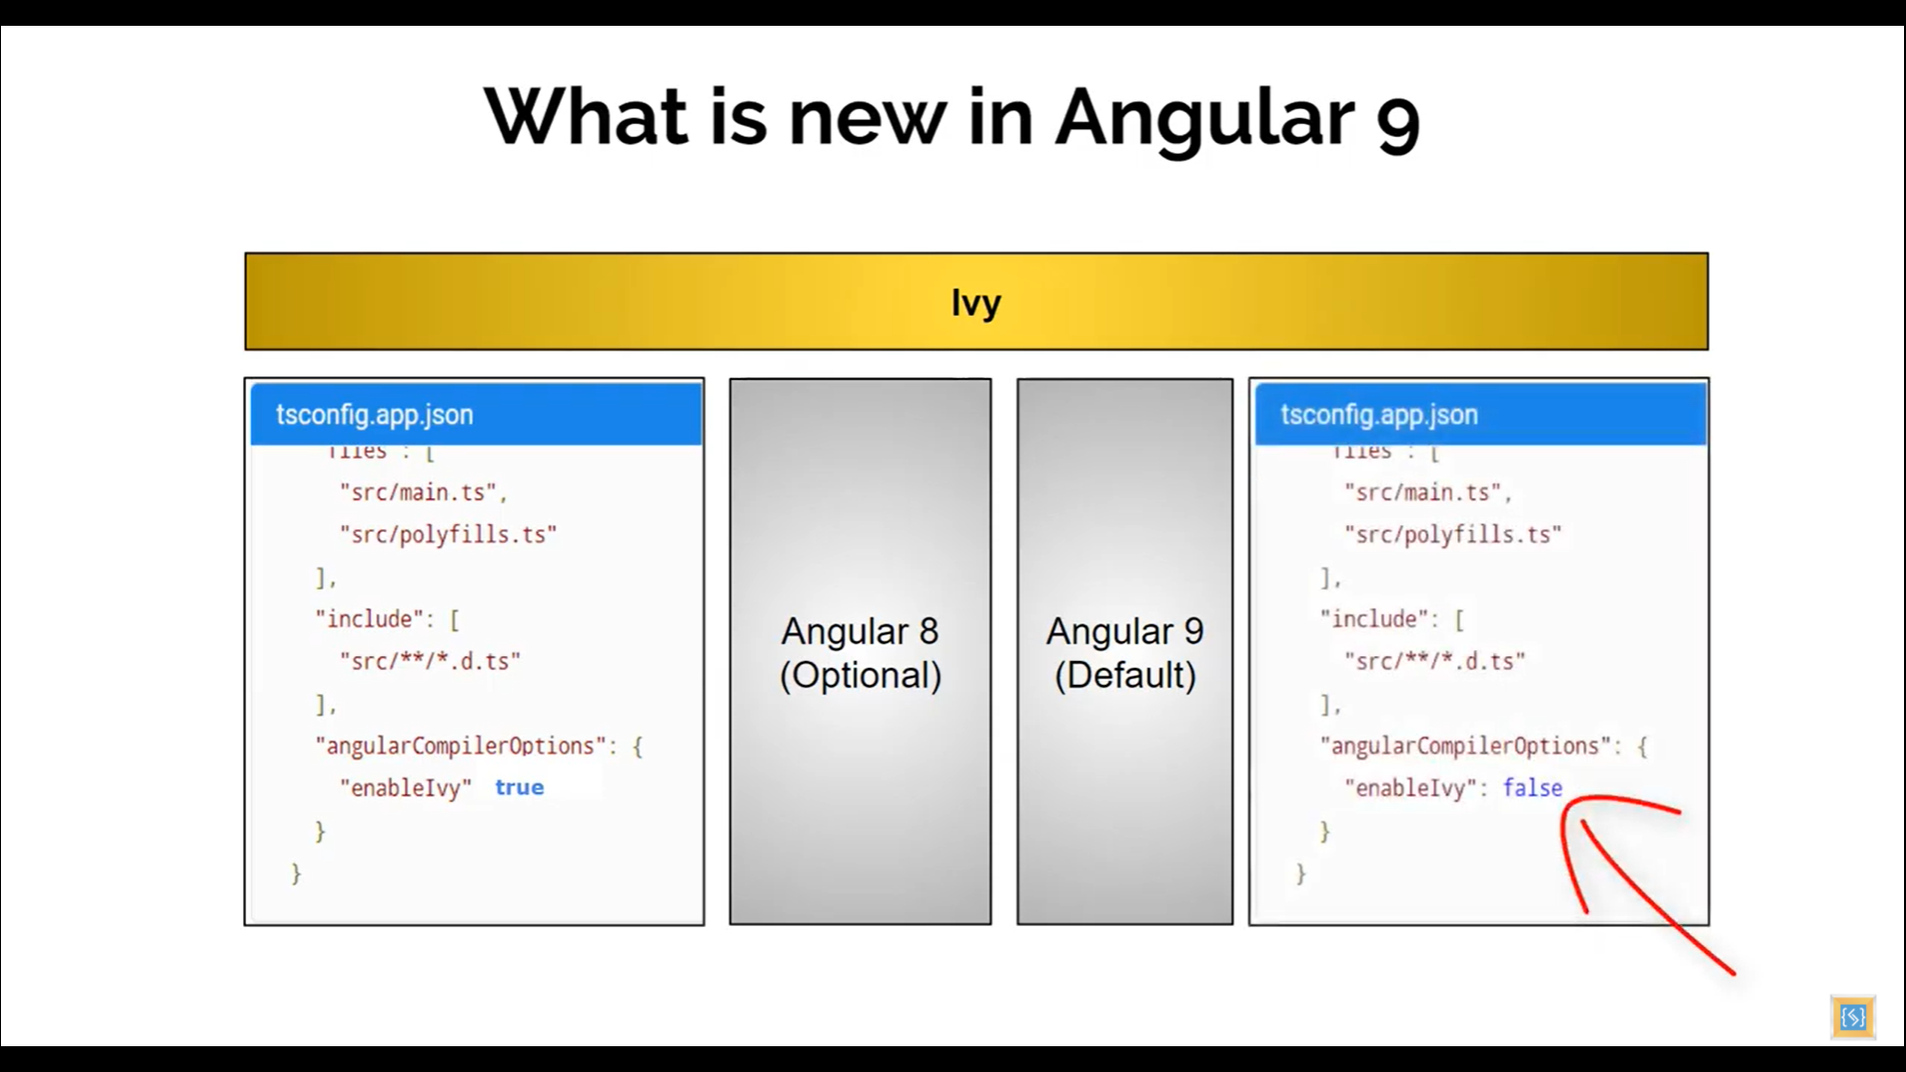

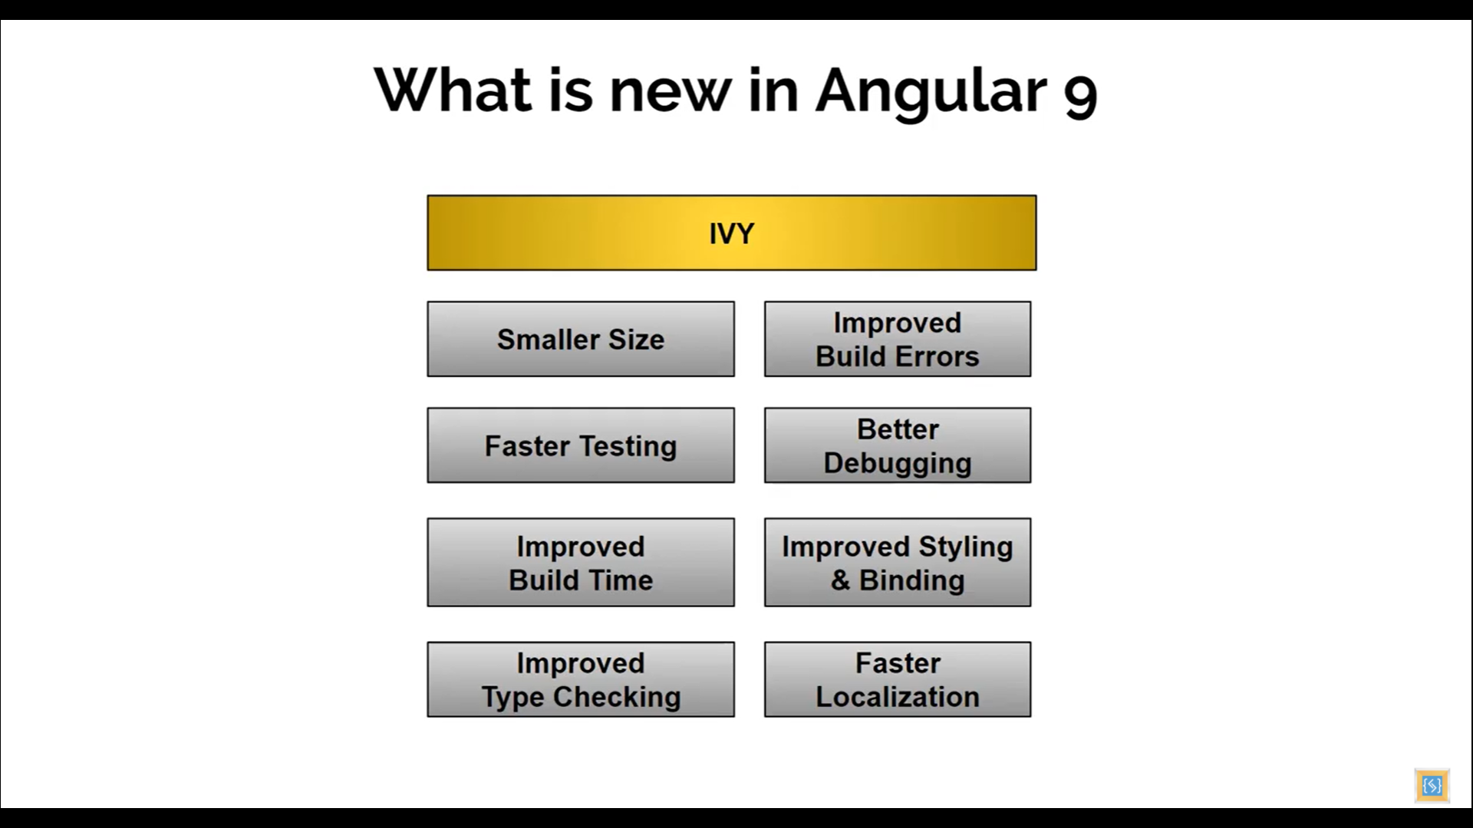

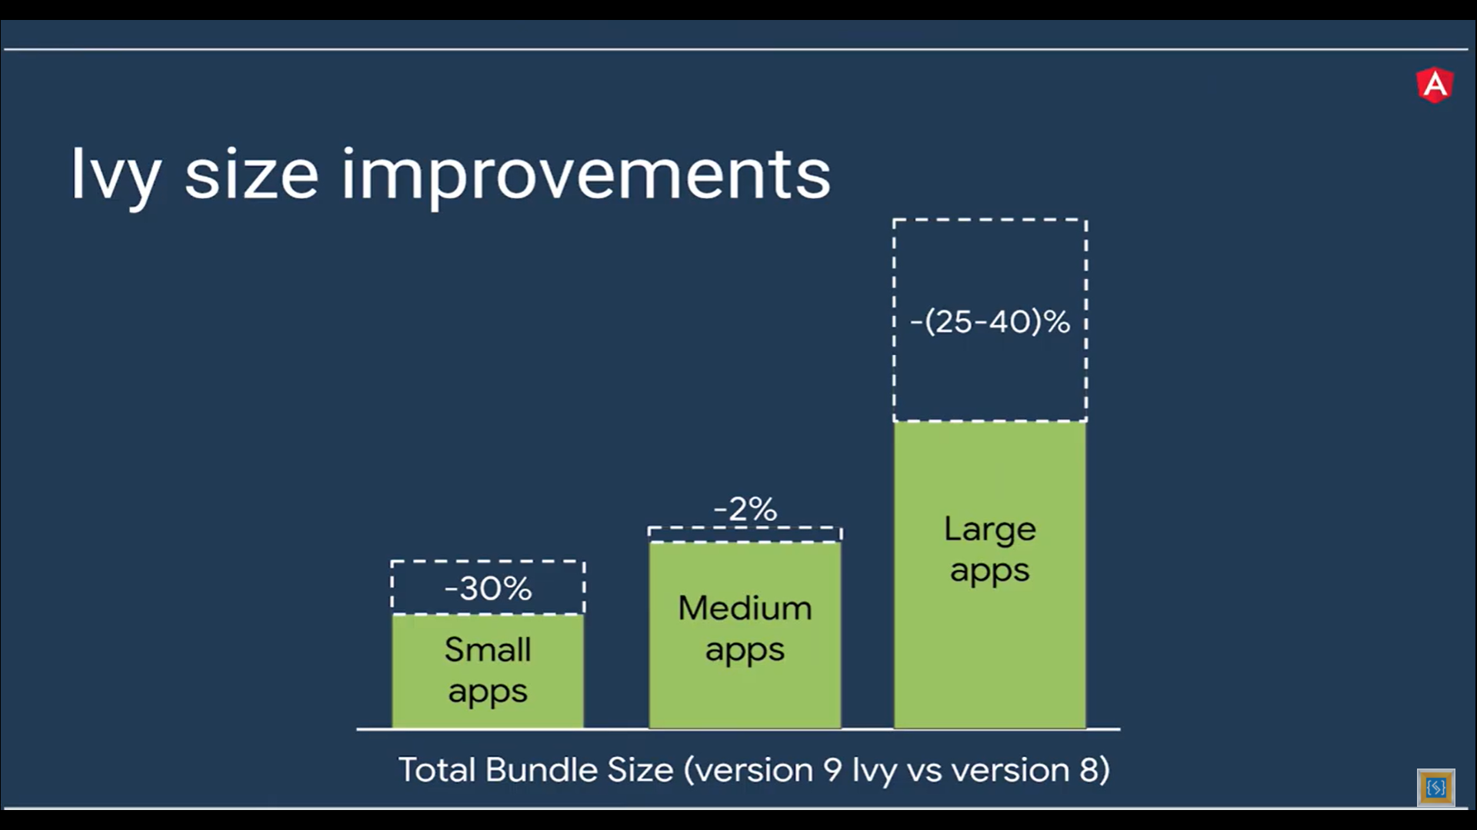

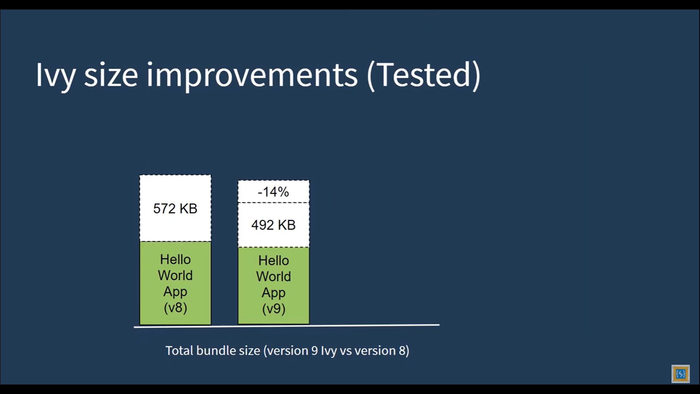

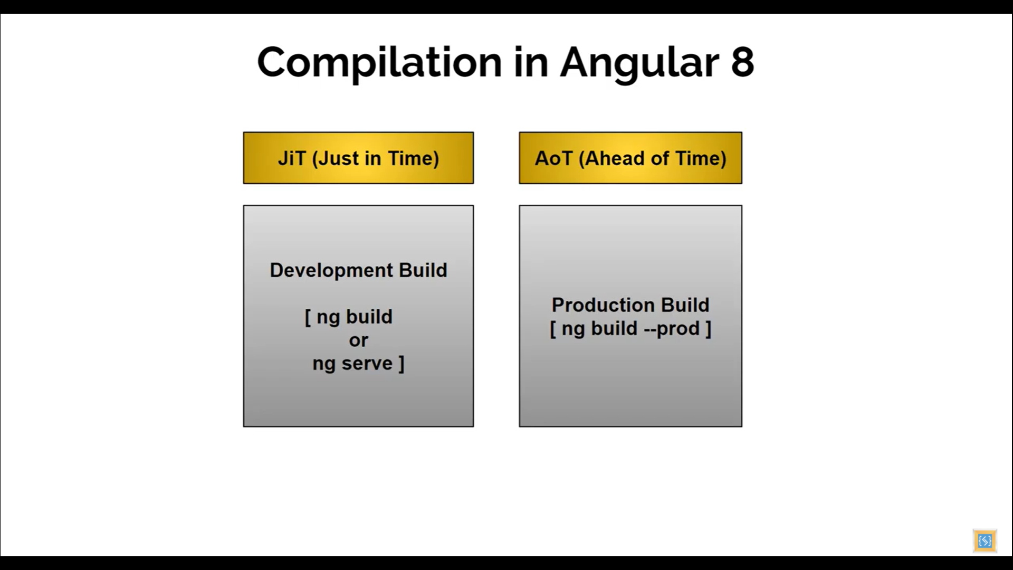

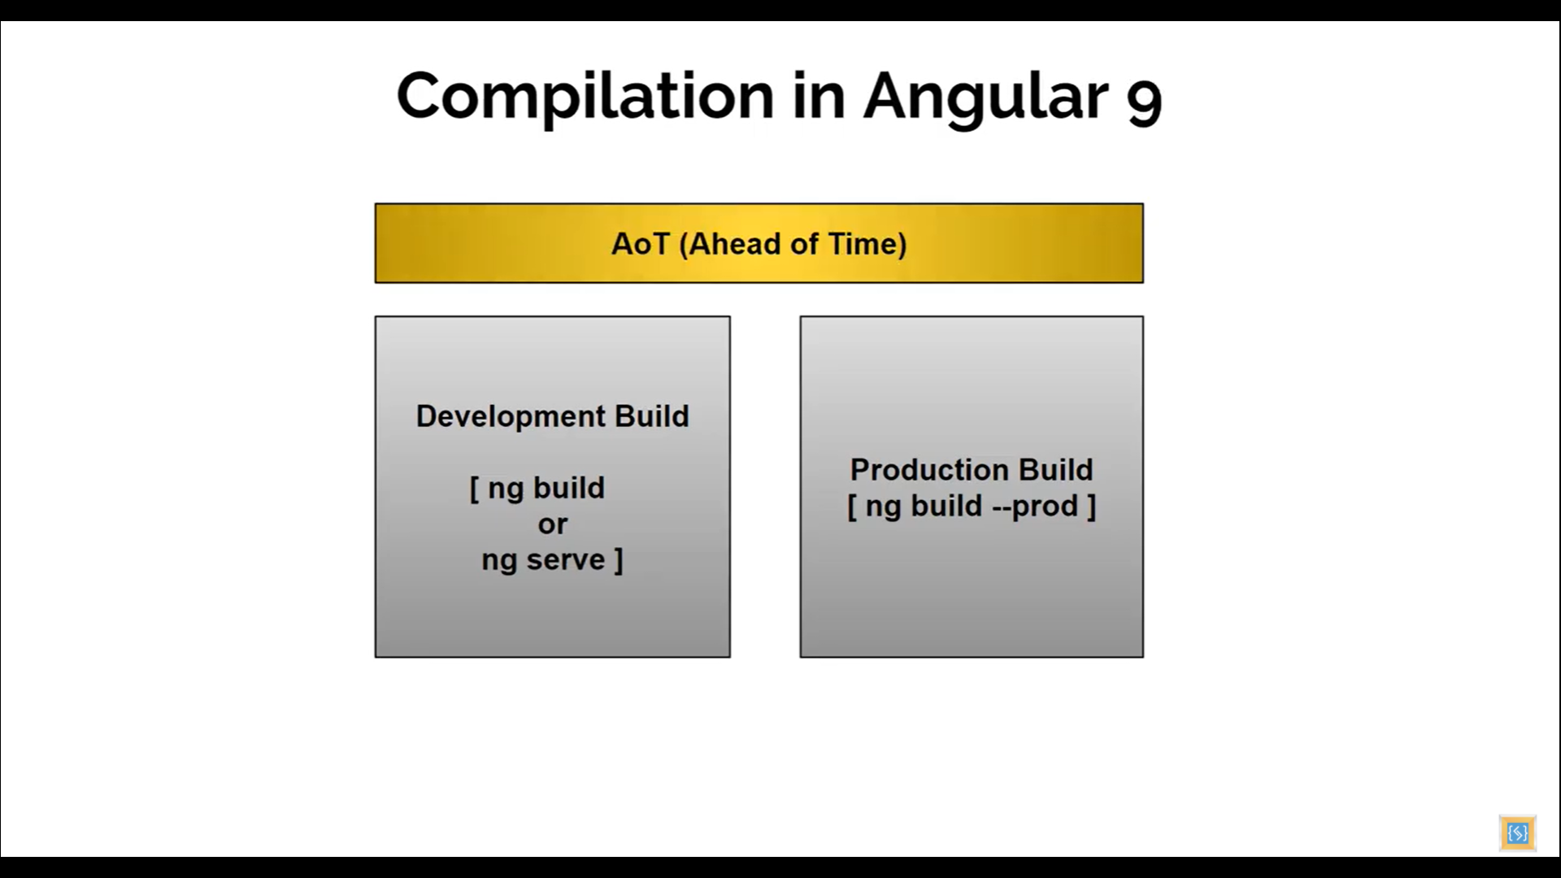

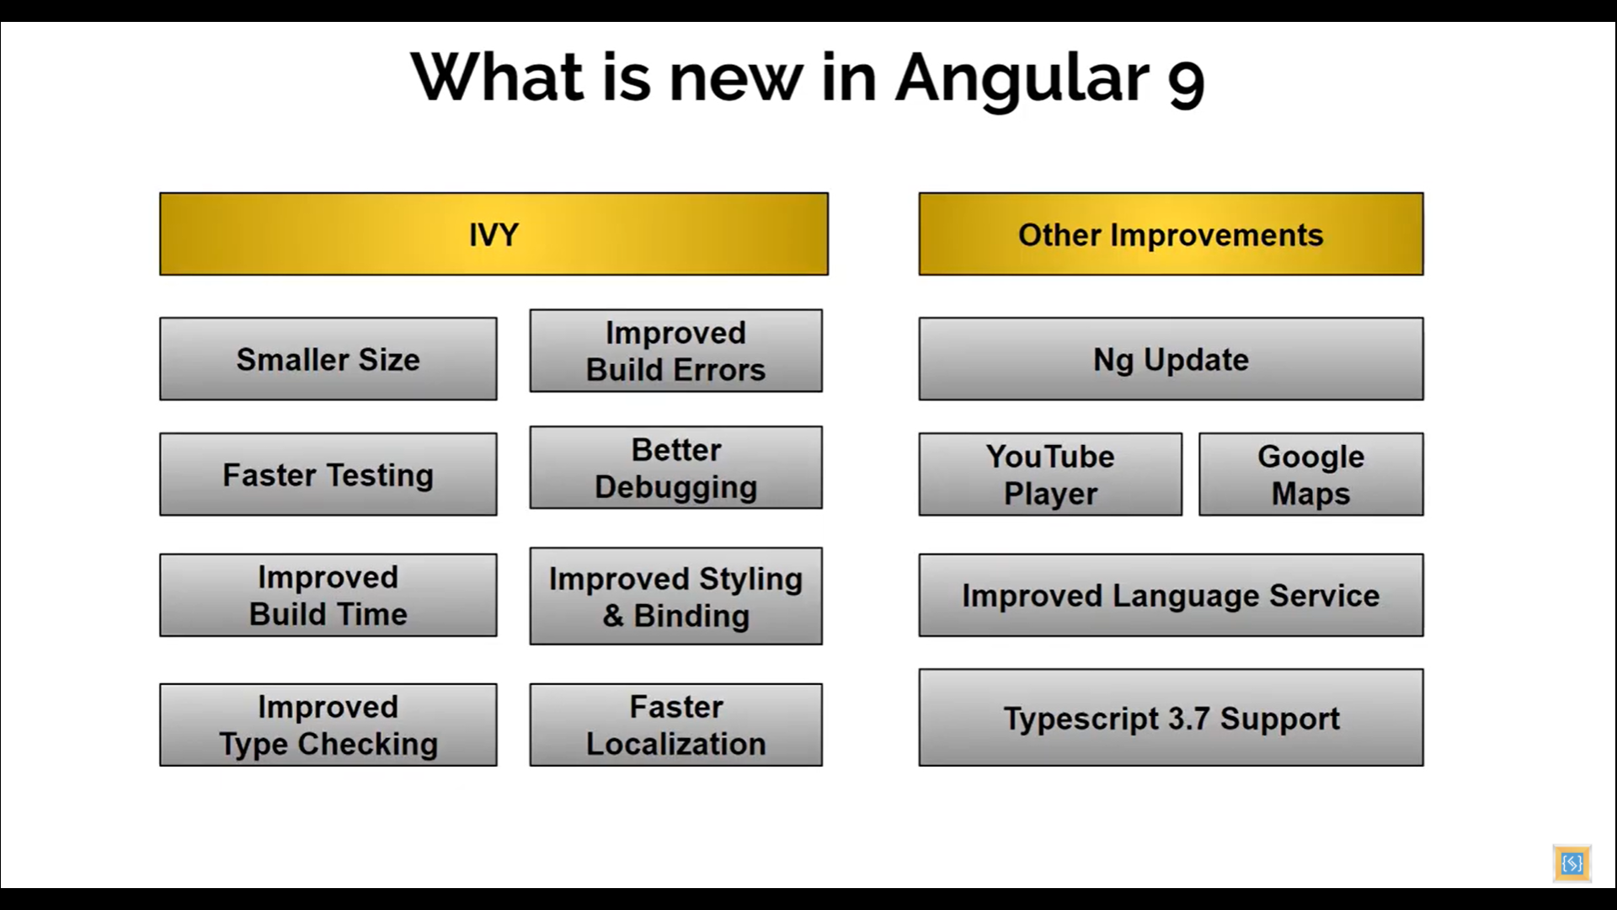

## Breaking changes in Angular 9

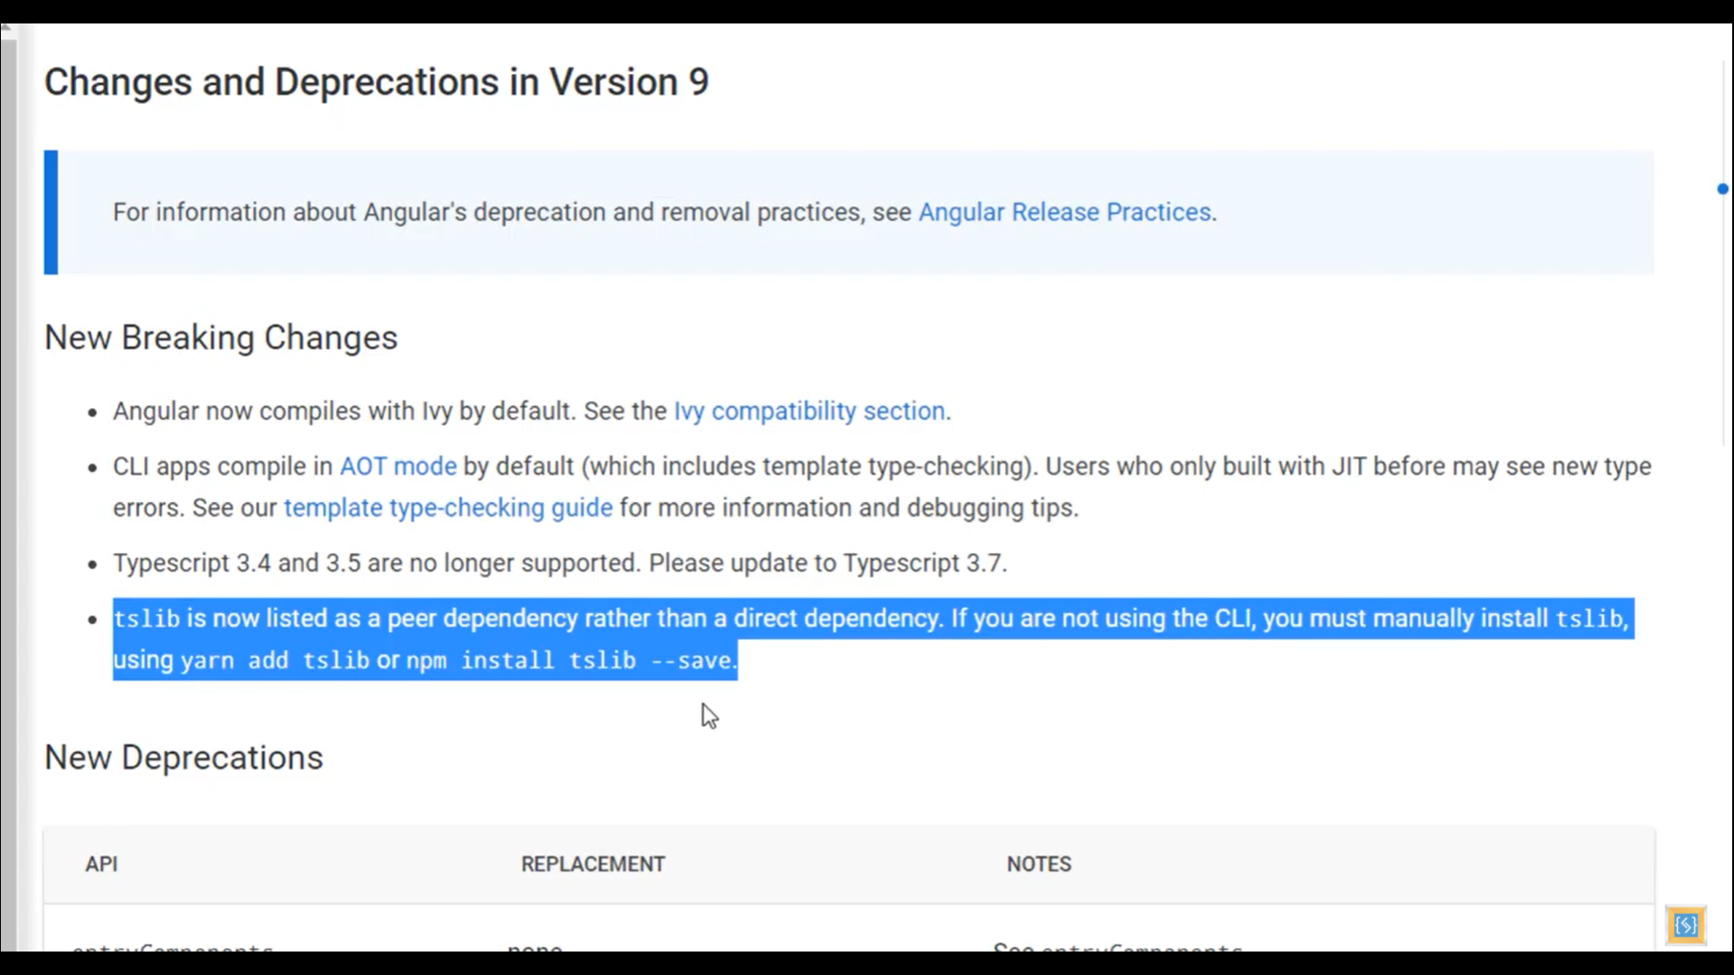

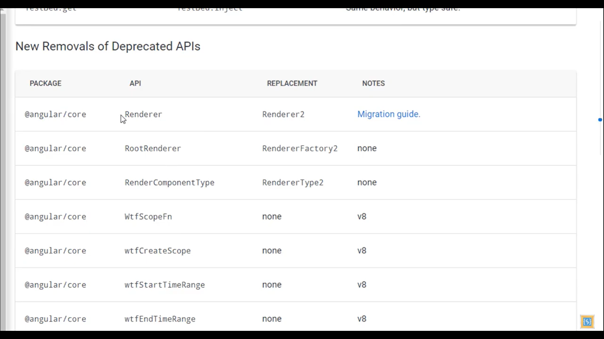

# Folder structure and flow of angular application

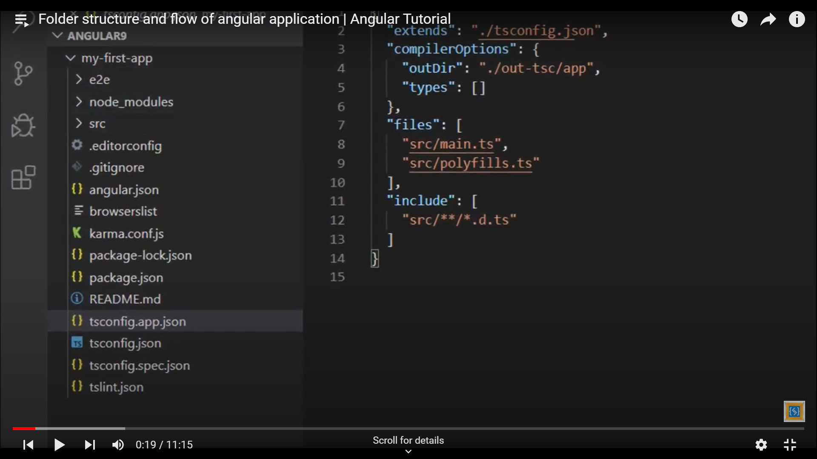

* e2e / karma.conf.js / tsconfig.spec.json
  + For integrated testing
  + For testing configuration
* node_modules
  + Contains packages and libraries
  + Packages are defined in package.json file
  + 2 types of dependencies defined in package.json which are dependencies and devDependencies
  + Dependencies packages are required in runtime and devDependencies are required during development
  + To install the packages when we download any code from external sources like git we can install them using terminal window by executing the command **npm install**
* src
  + This folder contains the source files
  + main.ts file is the entry point of the application
  + app.module is responsible for the bootstrapping of the application
  + app.component is where we define where is our root component
* .editorconfig
  + This file is not related to angular but its related to VsCode configuration
* .gitignore
  + Its related to git which is source control tool
  + It contains the files and folders list which we do not need to commit on source repository
* angular.json
  + Its angular CLI configuration file
  + It provides project configurations default for build and development tools
* karma.conf.js
  + This file is related to testing
* package-lock.json
  + The exact tree when the packages were installed which are defined in packages.json
  + It’s like a history and detailed view of packages installation in our application
* README.md
  + This file is a help file for useful commands for CLI
* tsconfig.app.json / tsconfig.json / tsconfig.spec.json / tslint.json
  + All these files are related to typescript configurations
  + tsconfig.app.json extends the tsconfig.json
  + tslint.json is the file where the typescript rules are defined and our typescript code is checked against these rules
    - We will get errors if any of our code violates these rules
* assets
  + Contains the images and other assets of the application
* pollyfills.ts
  + This script contains the code for providing the support of multiple browsers
* styles.css
  + This contains the global styles
* test.ts
  + This file is related to testing
* environments
  + There are 2 files under this folder
  + environment.prod.ts contains the details related to the production environment
  + environment.ts is the file which contains the details related to the development environment

## Angular Component

1. Angular is component driven and application is made up of multiple small components of specific functionality
2. And assembling all these components we can design a very powerful application
3. A component might have html file as view ,css files for styling and typescript file which will contain properties and functions which would be used in html template of that component.

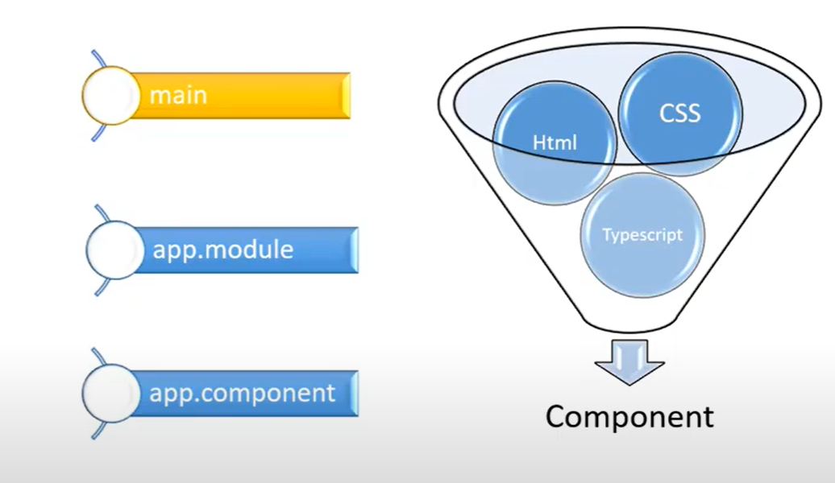

1. We can have multiple components in our application but there would be a single root component and all other components should be rendered as the child component

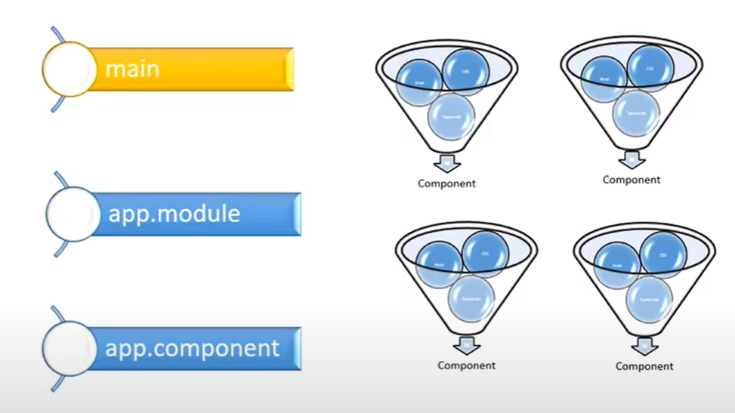

1. So by default app.component is our root component and is used In index.html
2. Index.html is the only page in the application and various other components are dynamically loaded in this Index.html

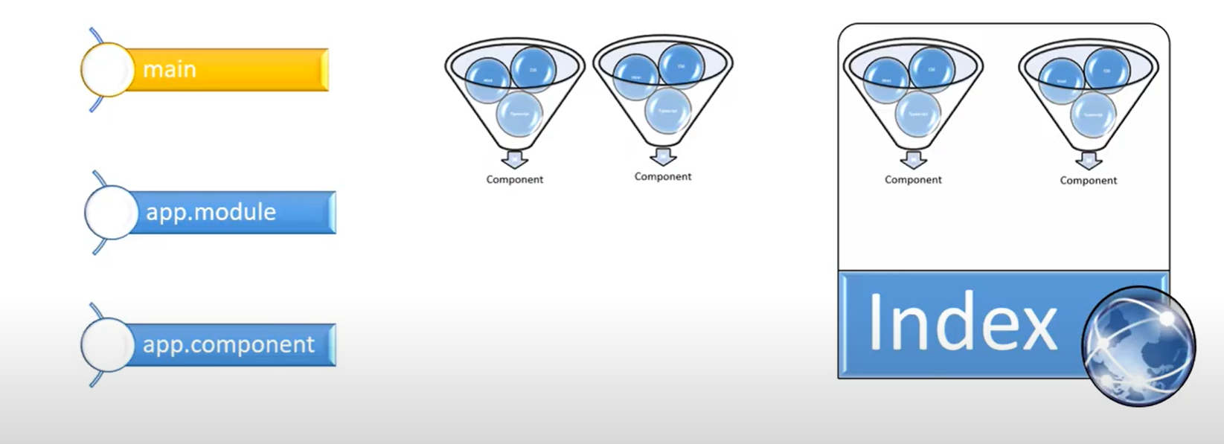

1. main.ts is the entry point of our application which is a typescript file
2. Typescript is the open-source programming language which is developed and maintained by Microsoft
   1. It’s a superscript of JavaScript and option static typing to the language
   2. Its JavaScript + some additional features

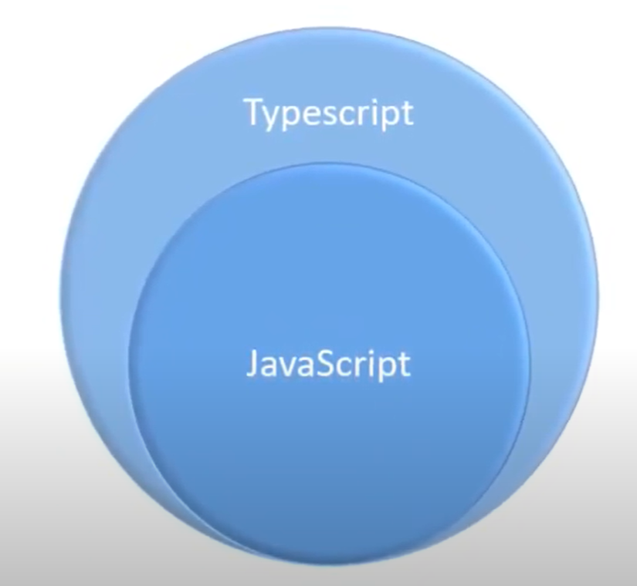

1. app.module.ts
   1. Any time we create a new component we need to add in the declarations statement of @NgModule of app.module.ts
   2. The imports list defines the modules used in our application
   3. The array of providers is where we want to add injectable services
   4. bootstrap : In this declaration we need to tell what needs to be bootstrapped and we need to setup which is our root component

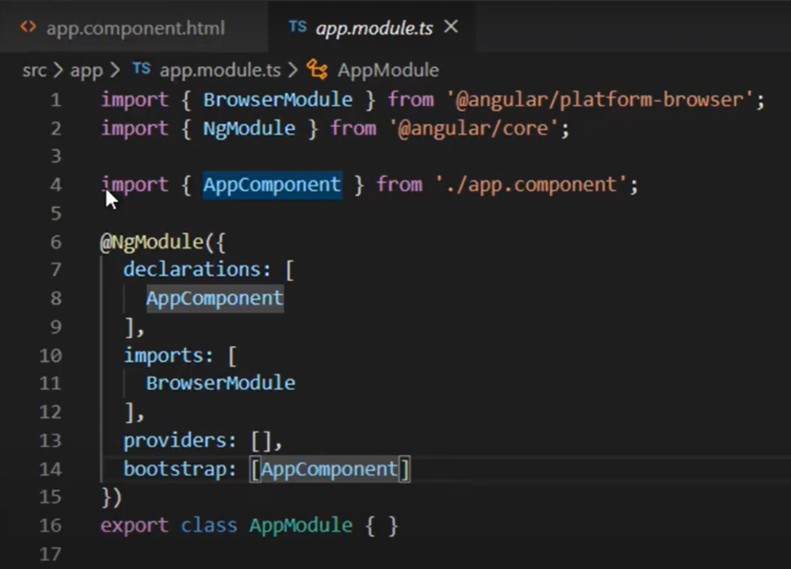

1. app.component.ts
   1. A component is made up of html , css and typescript
   2. We can define the path of html, selector, and style file for the component
   3. The selector defined in the component is used in the html
   4. The app.component.html file is where we define the html of the component

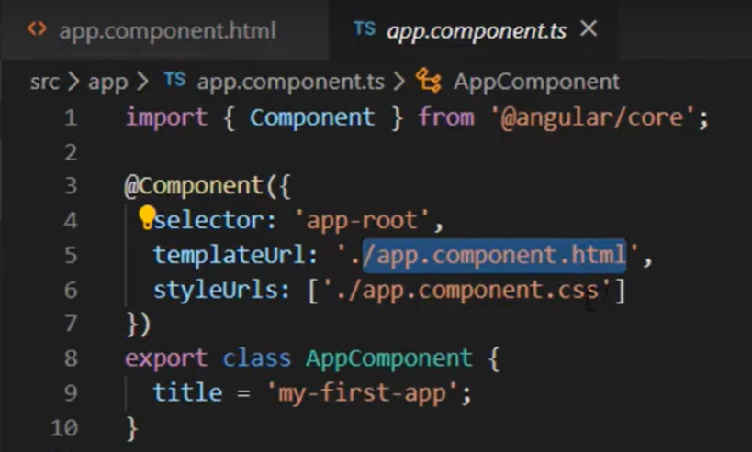

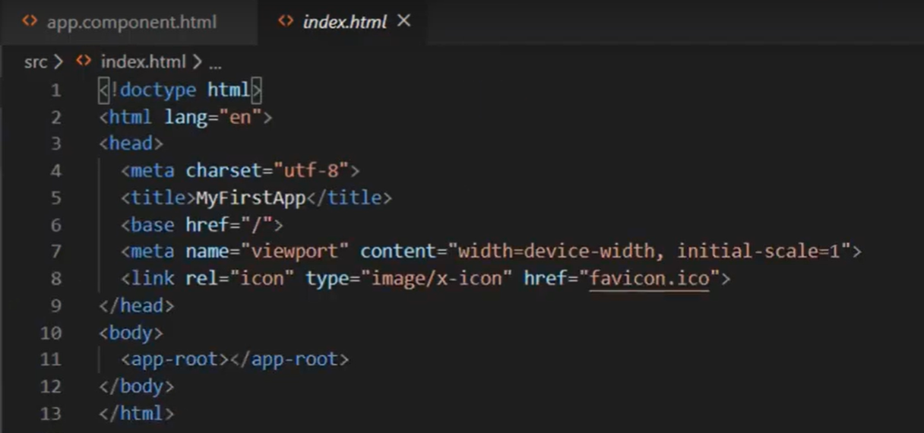

# Important angular extensions and multiple ways to create components

1. VSCode is lighter editor
2. We can browse and extensions and install in the VSCode
3. We can install extensions by using this below option and also search extension from marketplace

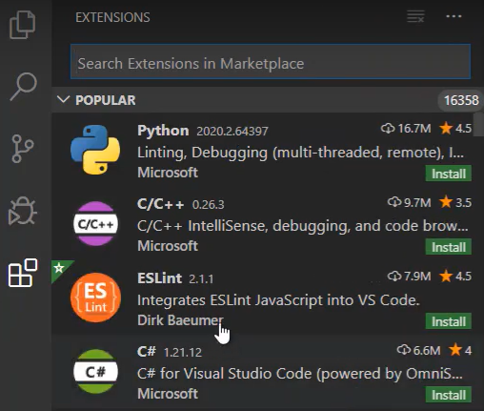

1. Important angular extensions for development are as below

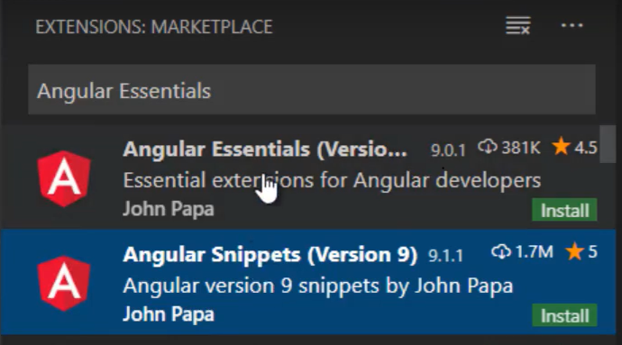

1. Angular Snippets :
   1. It provides the code snippet for html and typescript for speeding up the development
   2. We can press ctrl+s on windows and get the list of available snippets
   3. We can just type a- which will show the intellisense of various code snippets list

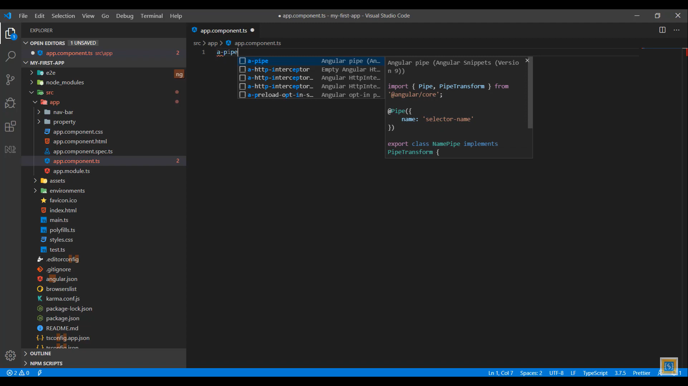

1. Angular Essentials extension is important to install
2. Another extension is “Auto Rename Tag” which automatically setups the closing tags for HTML and XML
3. Another extension is “Bracket Pair Colorizer 2” which adds color to pair of brackets to identify the opening and closing brackets easily
4. Next is “Angular Files” which helps to generate components , services faster through the VSCode editor instead of terminal
5. Next extension is “intellisense for css class names in HTML” which provided the intellisense for css class names in HTML

# Developing a sample application in Angular 9

We will create a property selling application

## Creating a homepage for our application

1. In this sample application homepage, we have 3 main components
   1. Navigation bar component
   2. Property list component
   3. Card component

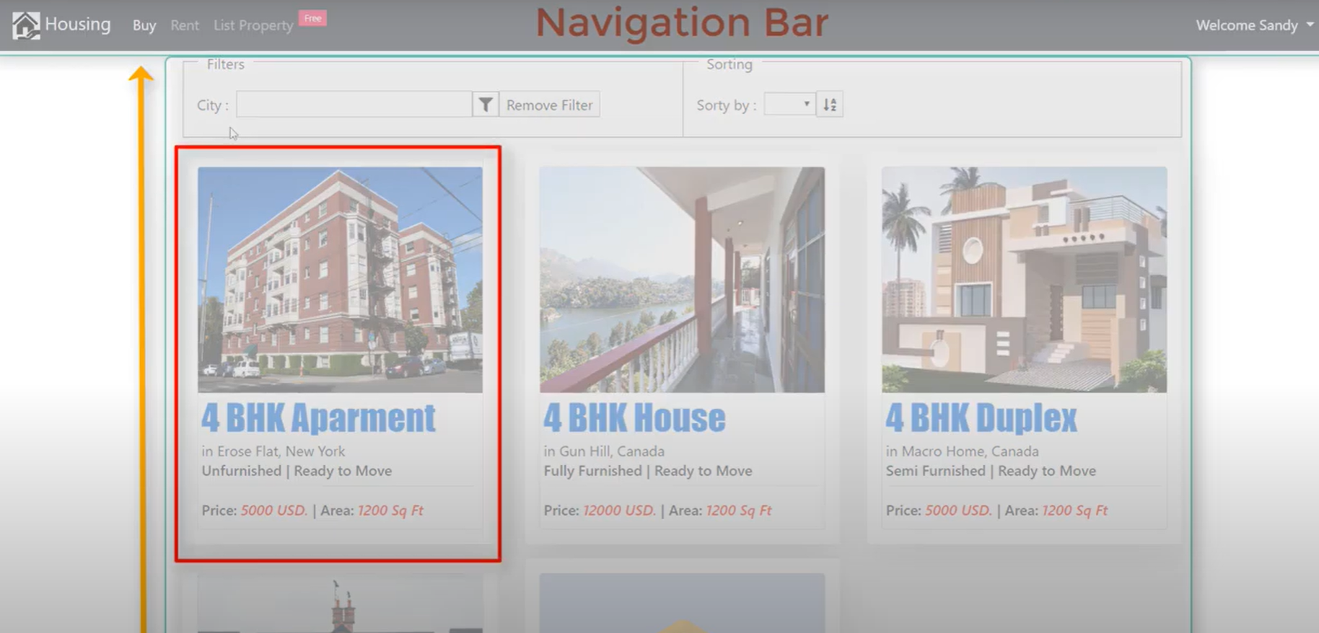

### Adding a property card component manually

1. Creating a property-card component manually here but we can add the component through CLI commands which will add the references in all the required files and boilerplates it too
2. As a best practice all the components code should be in the app folder
   1. Create a folder called property and property-card under it
   2. Add a new component with a proper standard naming convention like property-card.component.ts
   3. Add below code in it to start developing the component

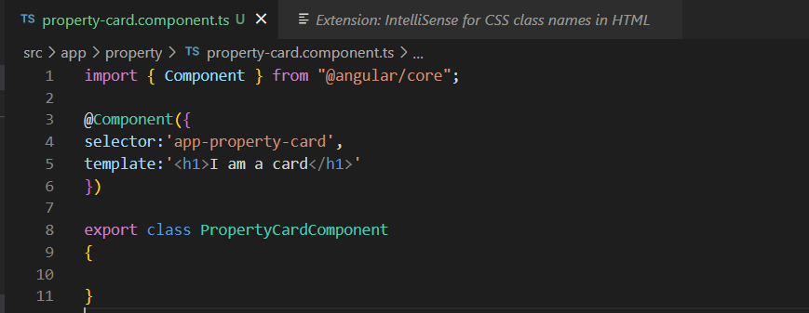

1. To check the component run the application by opening the new terminal from the VSCode by selecting Terminal-> New Terminal and type the command ng serve --open
2. To add this new component to our root component we will need to
   1. Go to app.module and add this new component in the module declarations
   2. It will also add the import statement which is add the details from where this component needs to be added

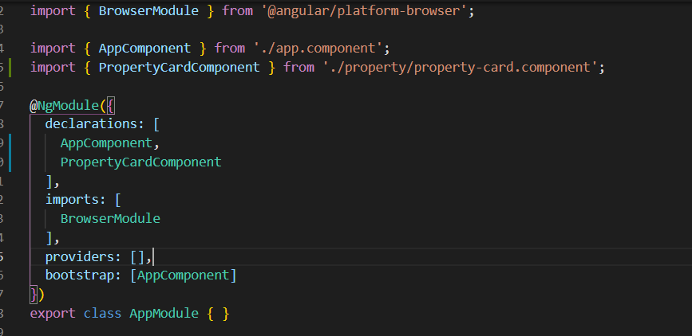

* 1. Now to add our property-card component in the root component we will need to add the below statement in it.
     1. Out selector for the property-card component is “app-property-card”
     2. Go to app.component.html and remove all the contents from there and add and save all

<app-property-card></app-property-card>

* + 1. Go to the browser which is connected with the terminal and you will see the below changes

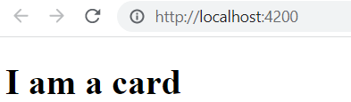

* 1. We can add styles as well in the typescript component as below but in the long run its not good practice to add the html , styles in the typescript file

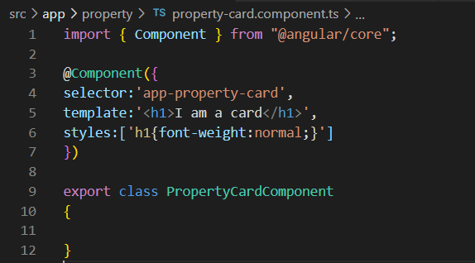

* 1. Also another disadvantage is that multiple team members won’t be able to work if the html , styles and typescript is added to same file.
  2. So, lets add a new html file called property-card-component.html and move the html to it
  3. Once this html file is added we will need to remove the template details and add the templateUrl with path of the html file as below

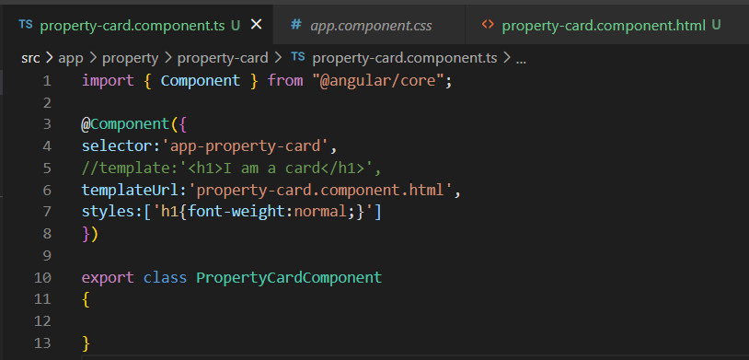

* 1. Same thing for styles we will create a separate css file to render
     1. Add a new file called property-card.component.css

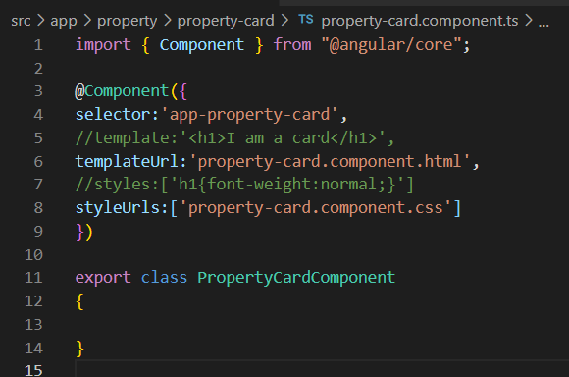

### Adding a property list component using CLI

1. We can add the new component from terminal by running below command on terminal

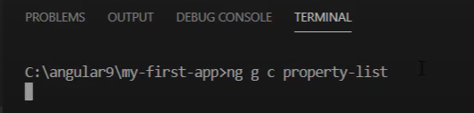

1. By default angular creates the component in the app folder when the commands are executed from the root but we can change the path from the terminal and can execute the command to create the new component in required structure as below

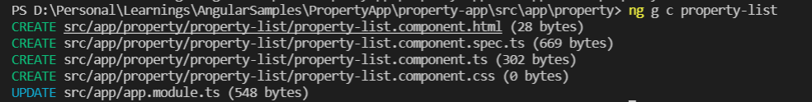

1. It would create the required component files and will also update app.module.ts

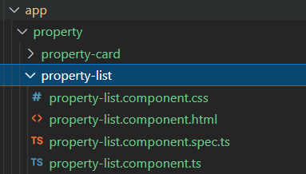

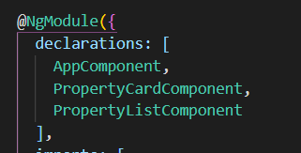

1. Let’s add this component to our home page to see if it’s working properly so add below in app.component.html and it will reflect In our home page.

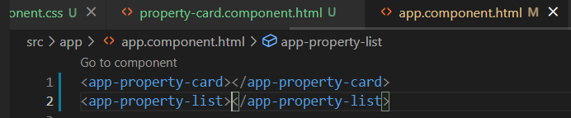

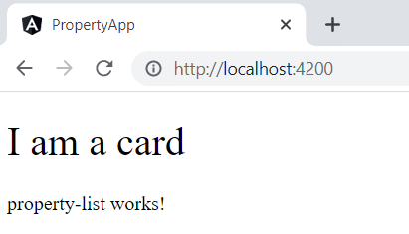

### Adding a component from VSCode environment

1. Now we will add a new component for nav bar and as its not related to property we will add this component in the app folder.
2. So right click on that folder and choose “Generate Component” and provide the name of the component like “nav-bar”

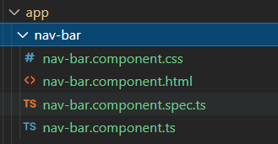

1. It will also add an entry in the app.module.ts in the ngModule list
2. Lets add this nav-bar component in the home page i.e app.component.html and see the changes in browser

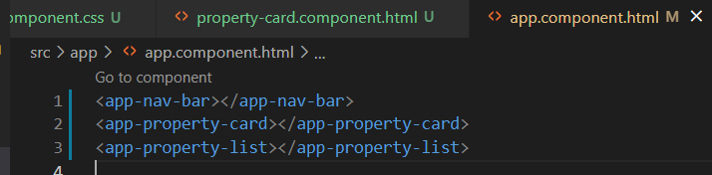

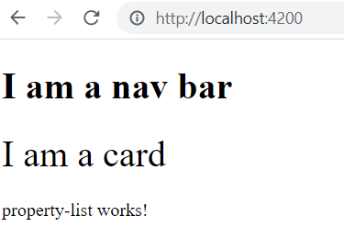

# Development hands-on for Property Application

## Adding Bootstrap and learning more on Typescript

1. Typescript file is like a code behind file for the component

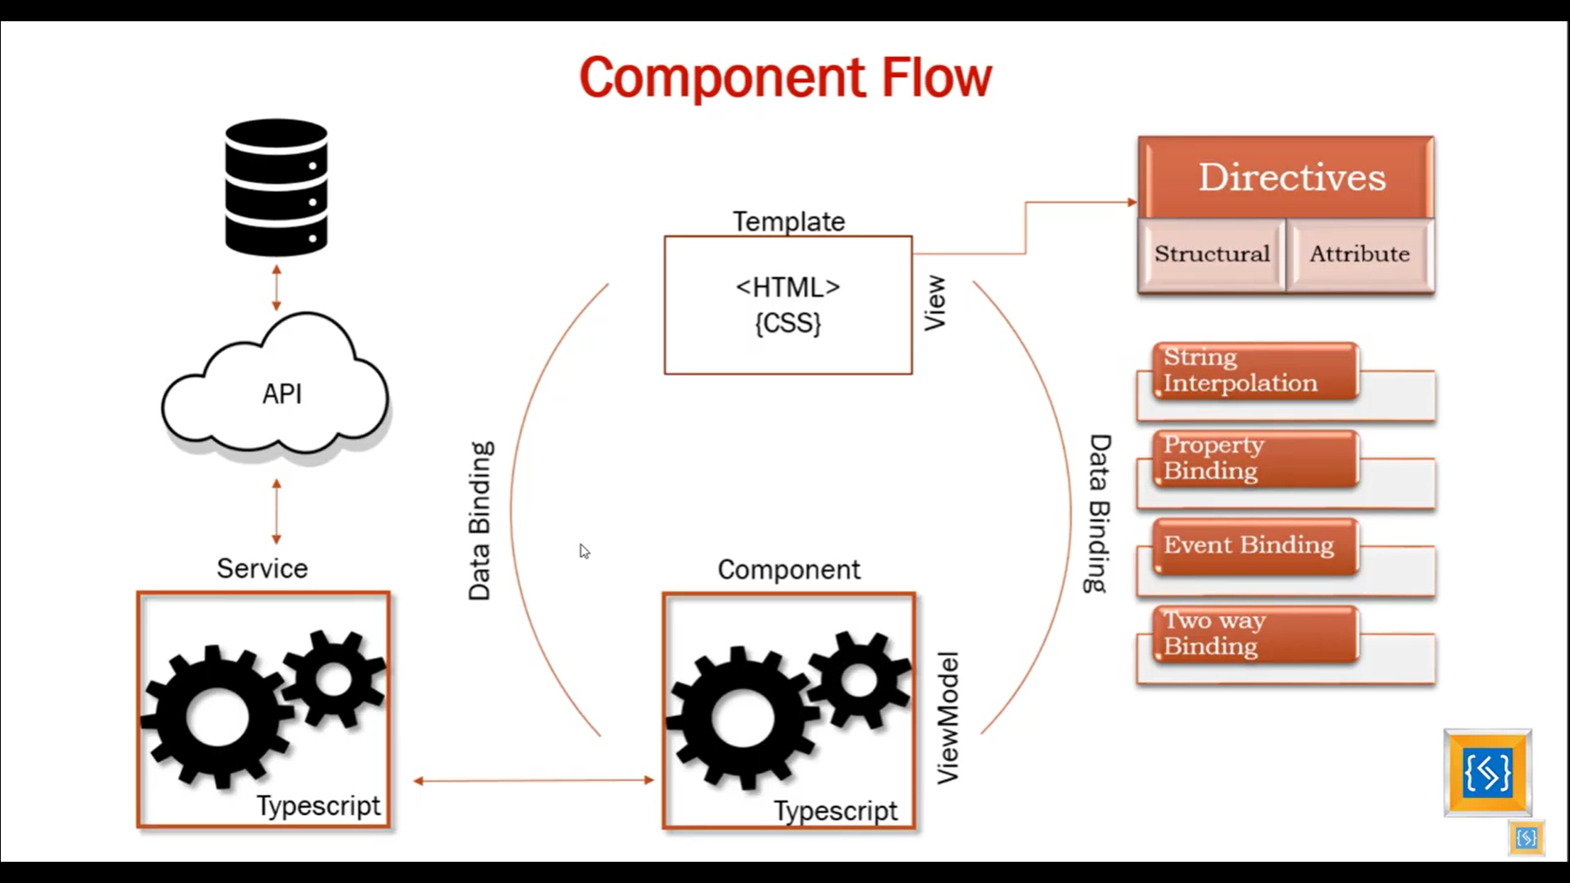

1. Below are the different ways of scripting in Angular but the most preferred language is typescript because its strongly typed language

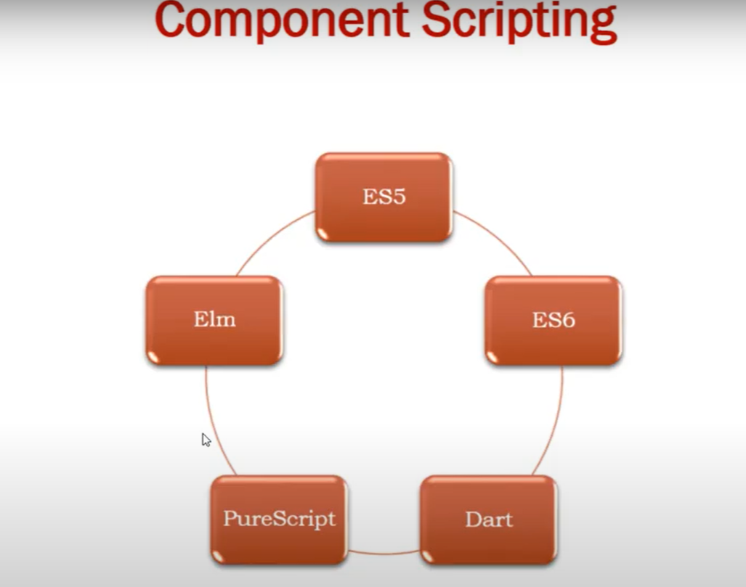

1. Typescript is superset of JavaScript
2. JavaScript does not understand the types e.g

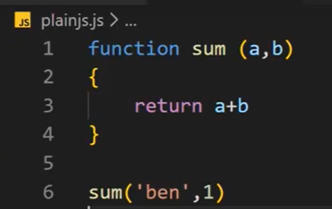

1. In the above function written in Javascript it won’t throw any error.
2. Writing the same in Typescript will lead to error because Typescript understands data types

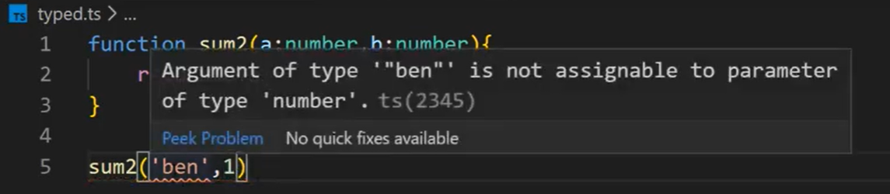

1. We can write object-oriented code in typescript

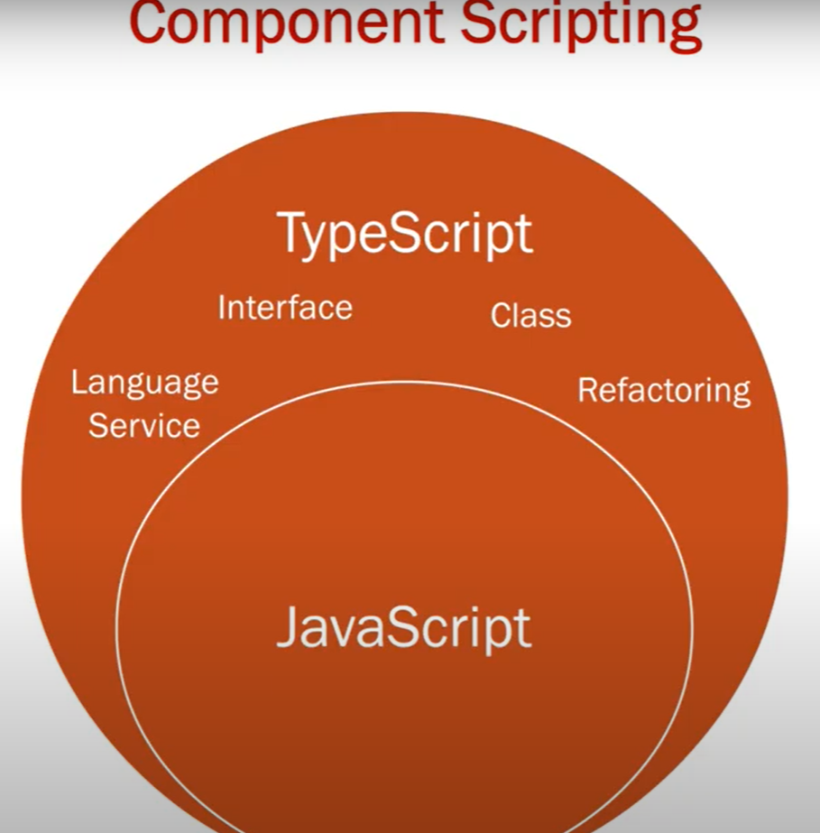

1. We can also write JavaScript inside typescript.
2. When we build the typescript code its converted to JavaScript by the process called “Transpile”



## Installing Bootstrap into your frontend application

1. Run command >**npm install bootstrap –save** from terminal
2. –save will add the reference in package.json file

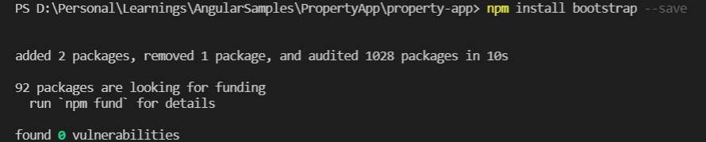

1. Add the reference in angular.json manually in styles section

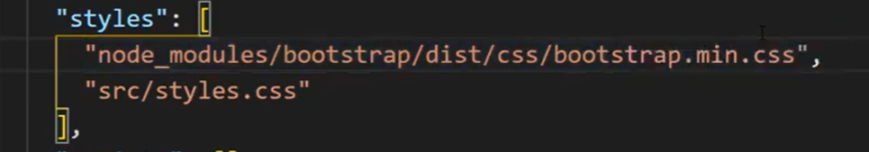

1. After that copy the nav-bar from the getbootsrap.com and paste it in our nav-bar.component.html and see the output



## Setting up the HTML for the property application

1. Copy paste the nav-bar html from GetBootstrap.com In nav-bar.component.html
2. Update the html of the nav-bar like this

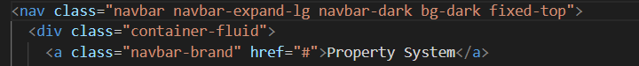

1. Update the app.component.html like below so that the home page is rendered properly with all the components inside it

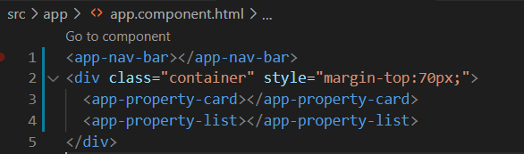

1. Post these HTML changes the home page will look like this

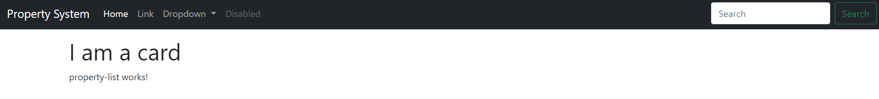

## Adding some properties to PropertyCard Component

1. We will add some properties in the PropertyCard component and will bind it with the html using string interpolation.
2. Adding the properties in PropertyCardComponent

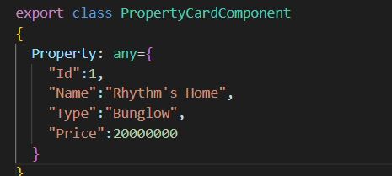

1. Binding the properties with the html

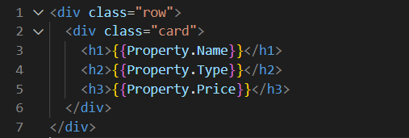

1. Adding the image to the property card and finally the card component will look like this

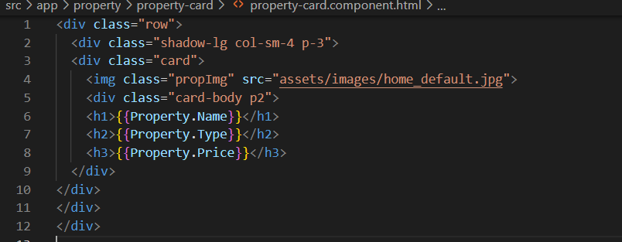

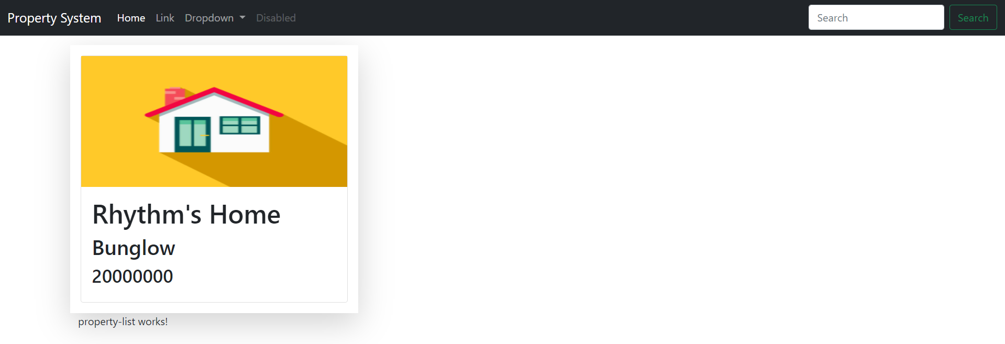

# Configuring GITHUB

1. Install GIT in your machine
2. Run below command



1. From 3 dots from below area first choose stage all



1. Run the below commands to provide your credentials for Git



1. Add the git repository



1. Push your changes

git push -u origin main

# Hands-on (Update Property list component)

What we will learn in this hands-on

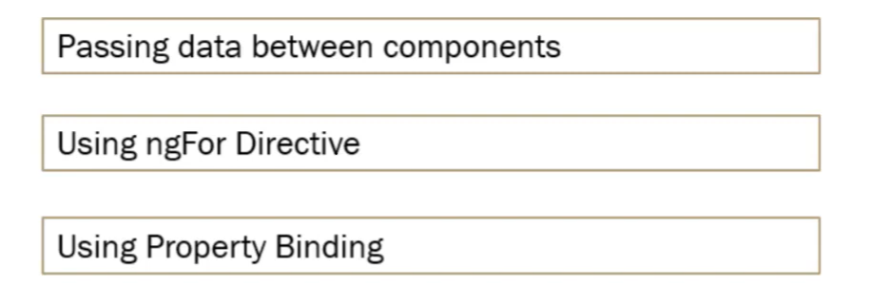

1. To bind the multiple cards in property list we would need to bind the data of properties from the property list component.
2. To do that we will need to create a collection of properties inside the property list component.
3. To do that create an array of Properties in the OnInit method of ProperyListComponent like below

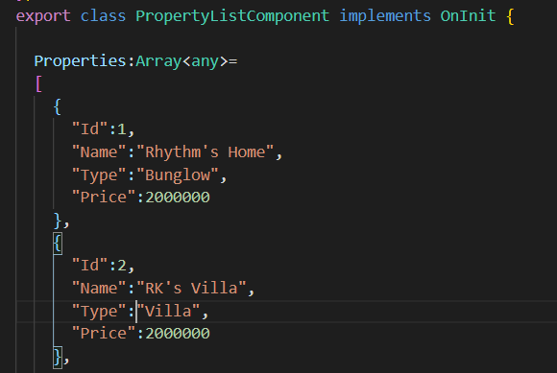

1. Now we need to place the property cards in the properties list component
   1. Add the below html in property-list-component.html to add the cards

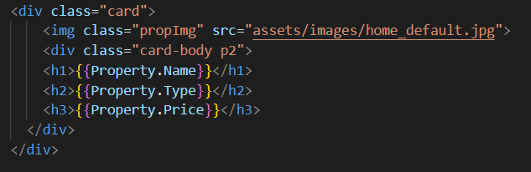

* 1. We need to bind the collection of properties defined in the property list component to property card component and render cards accordingly and to achieve this we need to add *ngFor directive in property list component as below
  2. Type a-ngFor to generate snipper for the loop like this

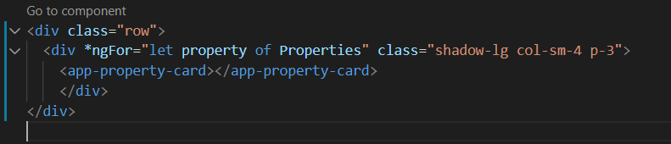

* 1. Remove the entry of Property card selector from the app.component otherwise it will lead to extra card
  2. So upto now the system will render the cards as below

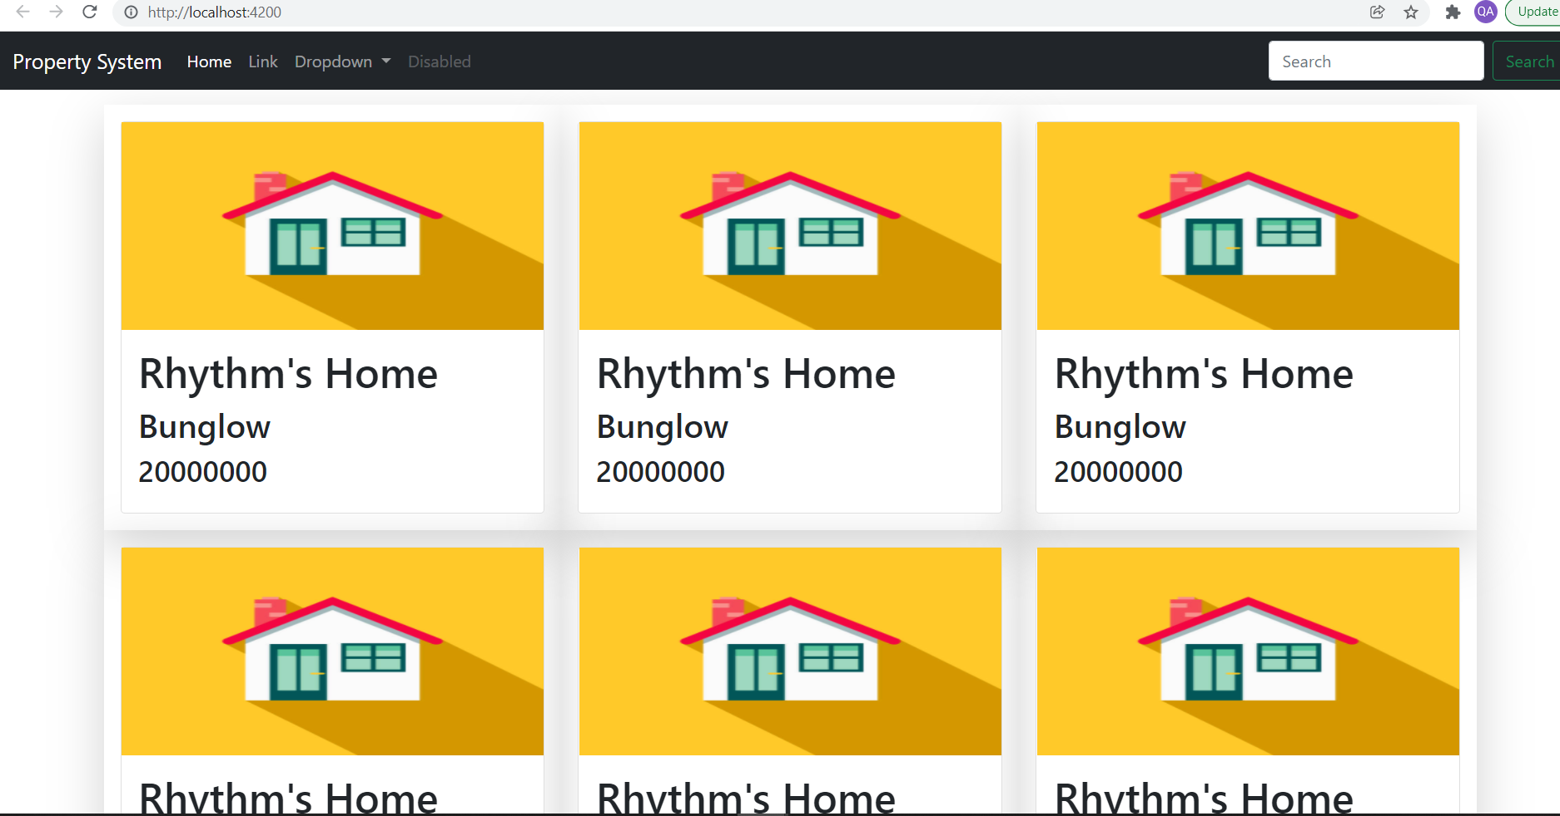

* 1. This shows a single card data which we have hardcoded in the card component but to pass the actual data from the properties collection we can achieve it like this
  2. We will use the input parameter and databinding approach called “Property Binding”
  3. In the property card component we need to declare an input parameter like this and use it in the binding in properties list component.

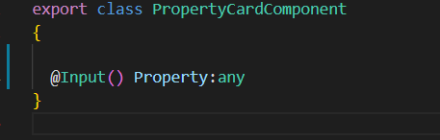

* 1. Change the html for the property list component to pass this input parameter to input parameter so that cards are binded with actual values

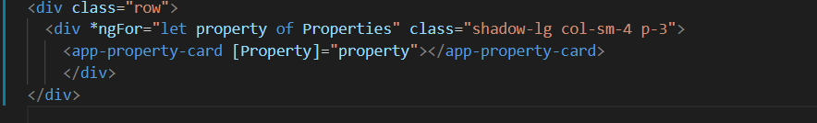

# Hands-On : Add CSS Animation to Property Card

1. This hands-on will explain us how to add effects on the card with the use of the css
2. Add the below css in property-card-component.css

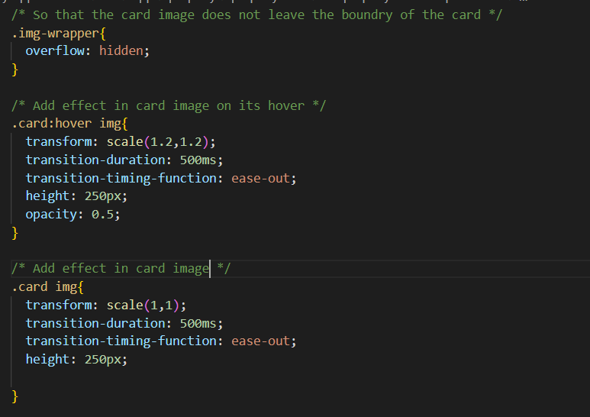

1. Change the card component html to as below

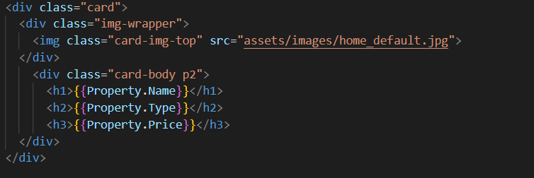

## Adding buttons on image with CSS effects

1. Add/update the below css in property-card-component.css file as below and this would be the final CSS for this change

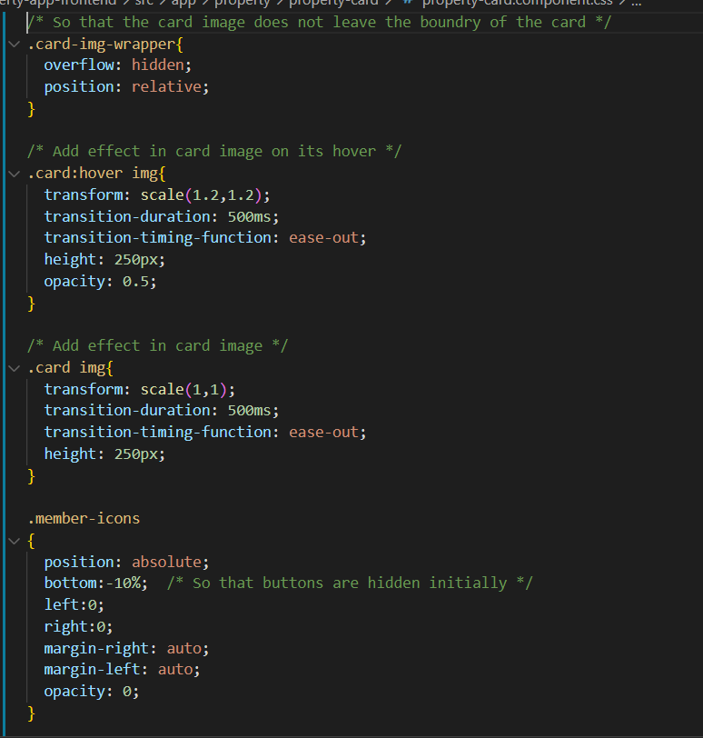

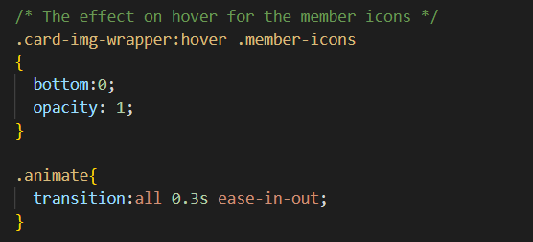

1. Add / update the below html in propert-card.component.html and below would be the final output after this change

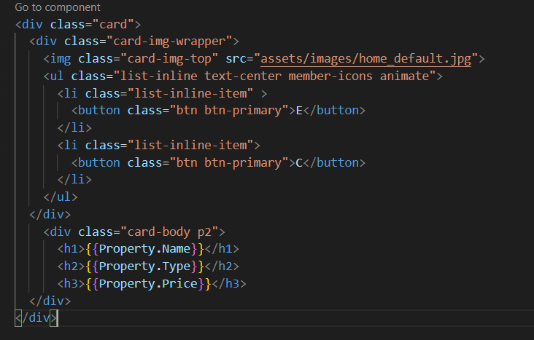

## Adding glyph icons instead of buttons

# Using Service and HTTP Calls in Angular 9

1. In this hands-on we will bind the properties data using http services to the cards using a static json file
2. Create a data folder in the assets folder and add a file Properties.json and move the array of properties we have placed hardcorded in properties-list.component.ts

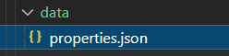

1. Add the entry of the new folder added in angular.json

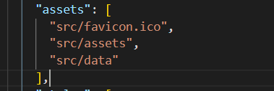

1. Add a package httpClientModule
   1. Go to app.module.ts file and add the import as below which provides methods for http requests



And also add in the imports list

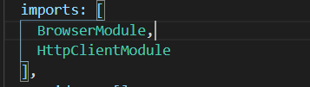

* 1. In properties list component we need to add the http client in the constructor whose object would be created at runtime

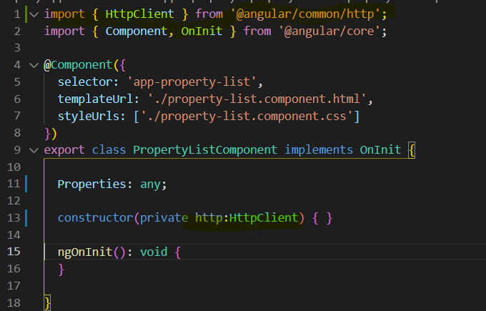

* 1. Now in ngOnInit() method we need to perform the call using get method

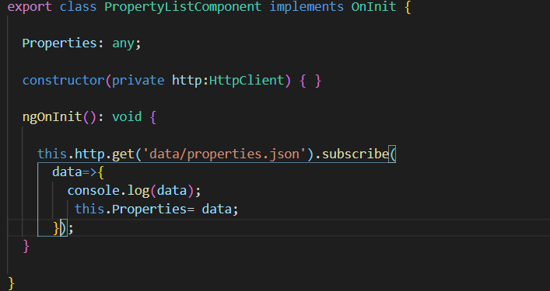

## Angular Services

1. What if there is need to share data between multiple components at that time services are very useful
2. Angular provides services that can be injected in various components using dependency injection.
3. Angular services are singleton objects which are instantiated only once during the lifetime of application.
4. The main objective of services is to organize and share the business logic , data and function with different components.

### Creating a service and fetch the property data

1. Create a services folder under the app folder
2. We can write the entire service code manually OR from VSCode menu OR can execute CLI commands to use the boilerplate to create the service
3. We are going to create a service to get all the properties and inject this service in the property list component
4. Add a new service called “Housing” using CLI like this
5. Navigate to the folder where you need to create a service from the terminal in our case its src/app/services folder

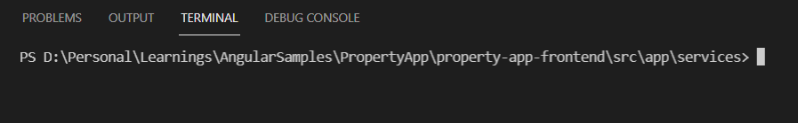

1. Run this command in the terminal



1. It would create the Housing service as below

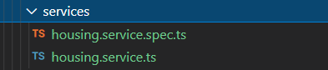

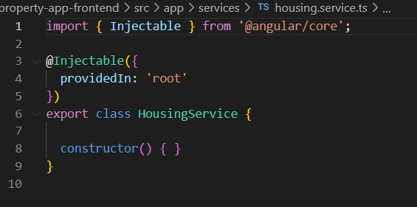

1. The service is injectable and “ProvidedIn” says at which level we are going to register this service
2. So in app.module.ts file in the “Providers” array register this service as below

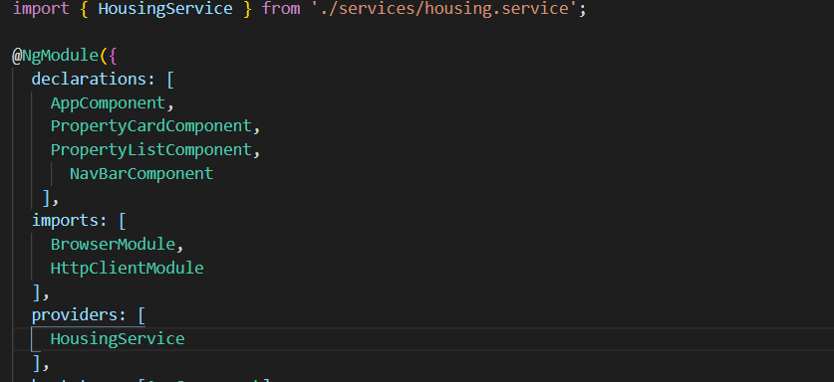

1. It will automatically add the import section at top and the single shared instance of the service would be created as its registered at the root level
2. Add the HttpClient to service constructor, add a method getAllProperties as below

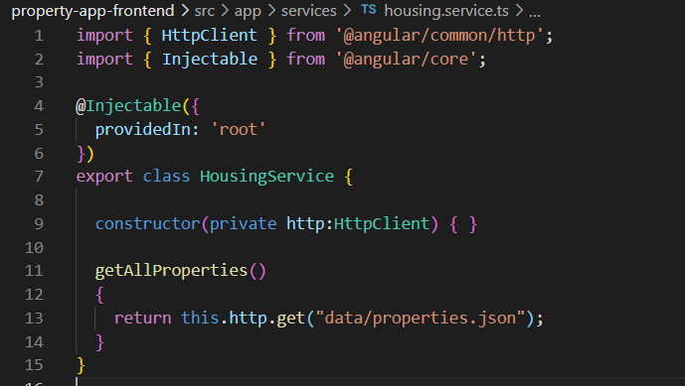

1. Remove the HttpClient import from properties list component , add the HousingService in the constructor of the PropertyListComponent and call the getAllProperties method in ngOnInit()

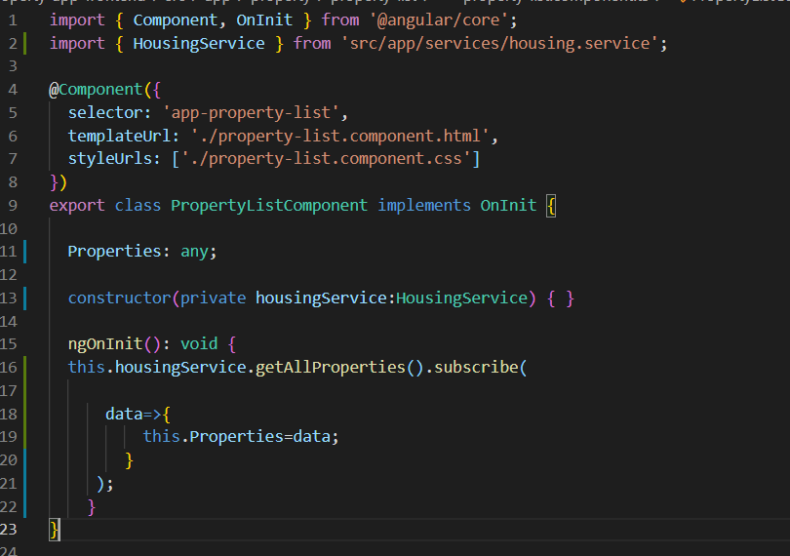

# Modify HTTP Data using Pipe

1. We will add the interface abstract to use for strict type binding instead of Any
2. We can do it using adding Interface by CLI command OR by VsCode menu
3. To use Pipe we will import the map operators where we need to add below line in “HousingService



1. This will help us to iterate over the observable collection returned from the response and for that we need to change the below code of “getAllProperties” method
2. Now add a new file under Property folder called “IProperty.Interface.ts”

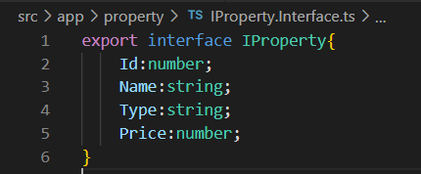

1. Change the code of housingService.ts as below

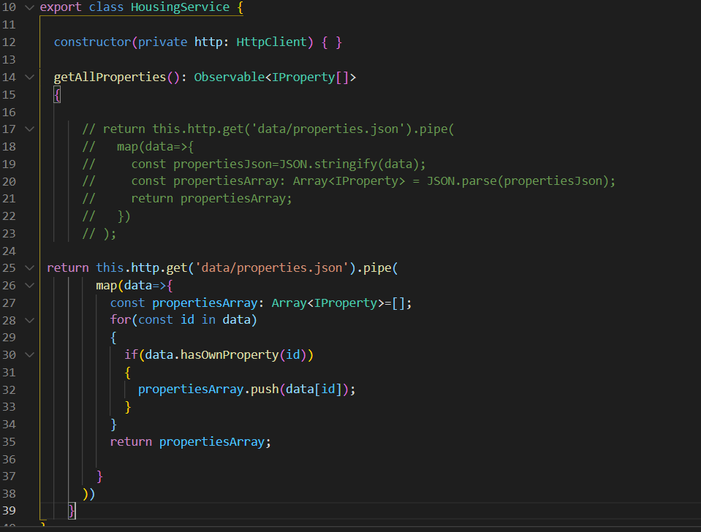

1. Also add below 2 settings in tsConfig.json in “compilerOptions”

"strictPropertyInitialization": false,

    "suppressImplicitAnyIndexErrors":true,

1. Also change the type of any to “IProperty” in property-list-component.ts and property-card.component.ts

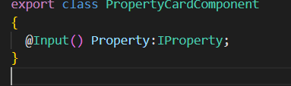

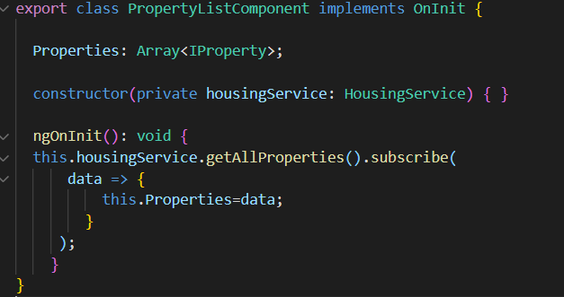

# Understanding Routing Part-1

1. Lets update the nav-bar html to add menu for buy, sell and list properties.

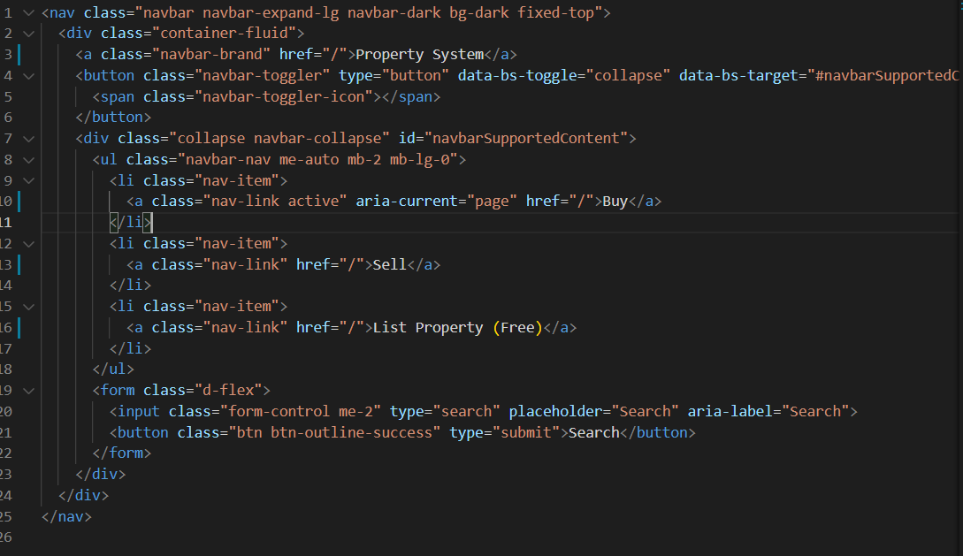

1. To add the different components dynamically as it’s a single page application
2. Lets add another component called add-property under property folder and register this component in the app.module.ts

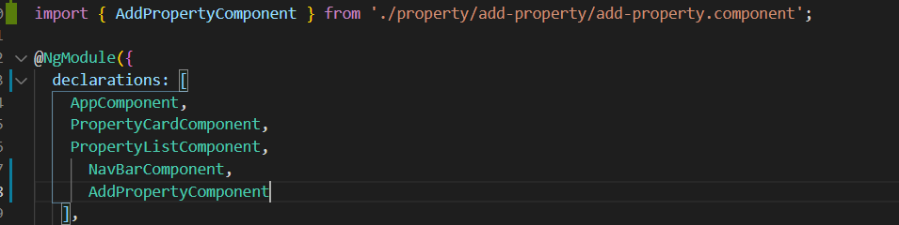

## Enable Routing in the application

1. To enable routing in the application we will need to import routing module as below in app.module.ts



1. Now we need to configure the routes for our app which we can do by defining the configuration in app.module.ts like this

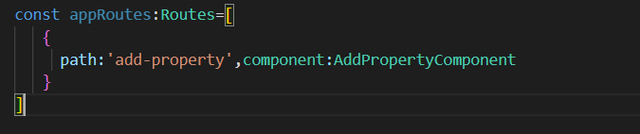

1. Now we will register this configuration in imports collection defined in the app.module.ts like this

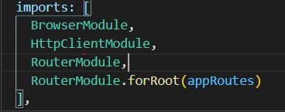

### How to configure the routing to load the components dynamically from the index page?

1. As of now by default we have rendered property list component in the index page i.e app.component.html like this

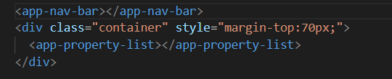

1. We need to first remove it and add router outlet which is provided by Angular which will take care to render the components dynamically

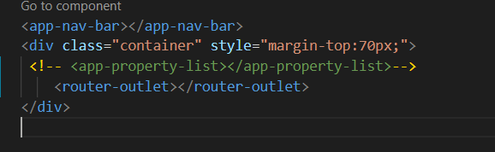

Finally the nav-bar.html and app.module.ts would look like this

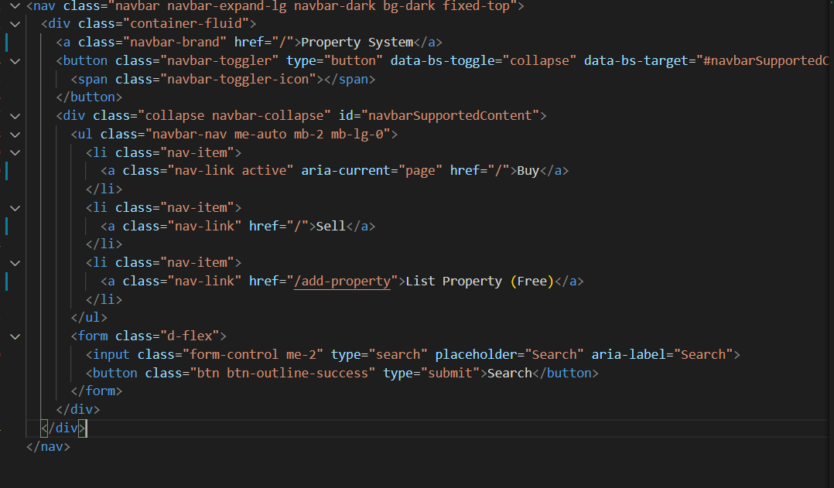

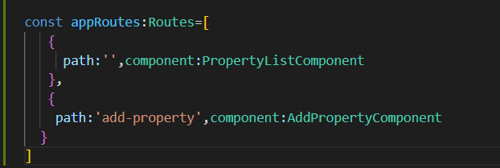

But the problem here is like the page is getting refreshed every time

# Routing Part 2

To overcome the problem of page refresh every time which also pre-sets the data being passed from one component to another we need to do following to overcome it.

To overcome this problem Angular provides the approach of setting the navigation through “routerLink” to perform the navigation instead of href

After changing the nav-bar.html it would look like this

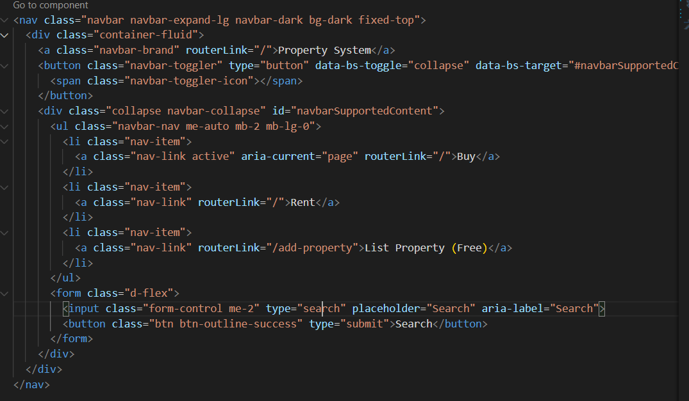

## How to make the selected menu active only and rest of the menu’s disabled

Angular provides “routerLinkActive” attribute where you can pass the “active” class to make the menu active. And also we can set [routerLinkActiveOptions]=”exact:true” to ask Angular to match the exact url

Changes in app.module.ts in routes array

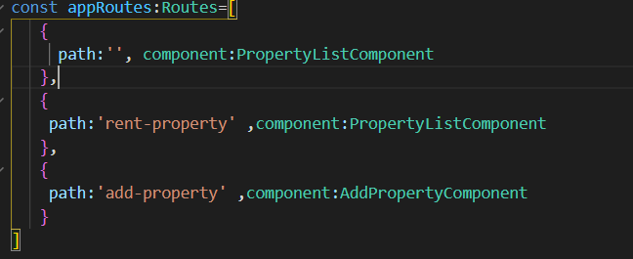

And the nav-bar.component.html changes are as below

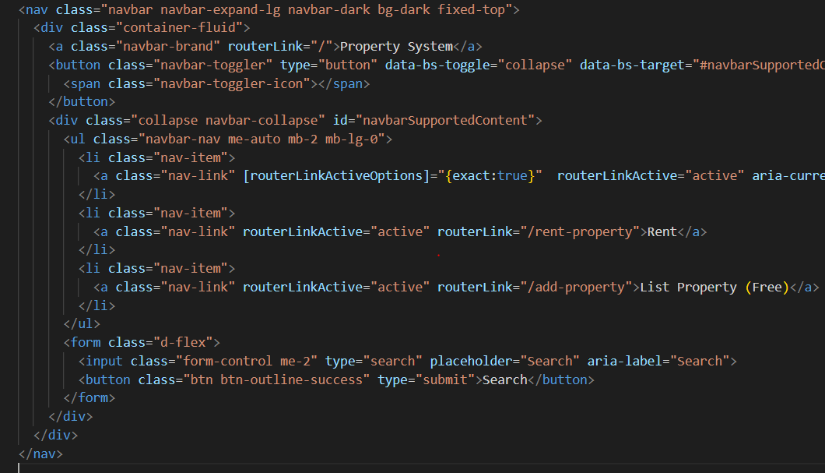

## Adding a new Property Detail Component

1. Now in the property card page we have placed a button to see the property details and for this add a new component called property-detail under property folder and lets link it with the property card.

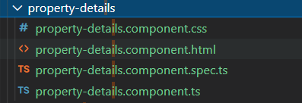

1. Add the entry of this component in app.module.ts under declarations and also add the new path in Routes collection as below

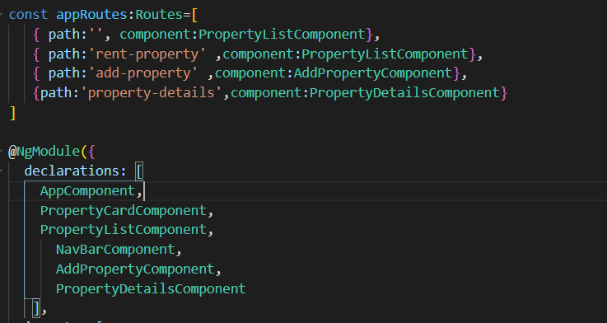

1. Set the route link path in the property-card component as below so that clicking on button should navigate the user to property details component.

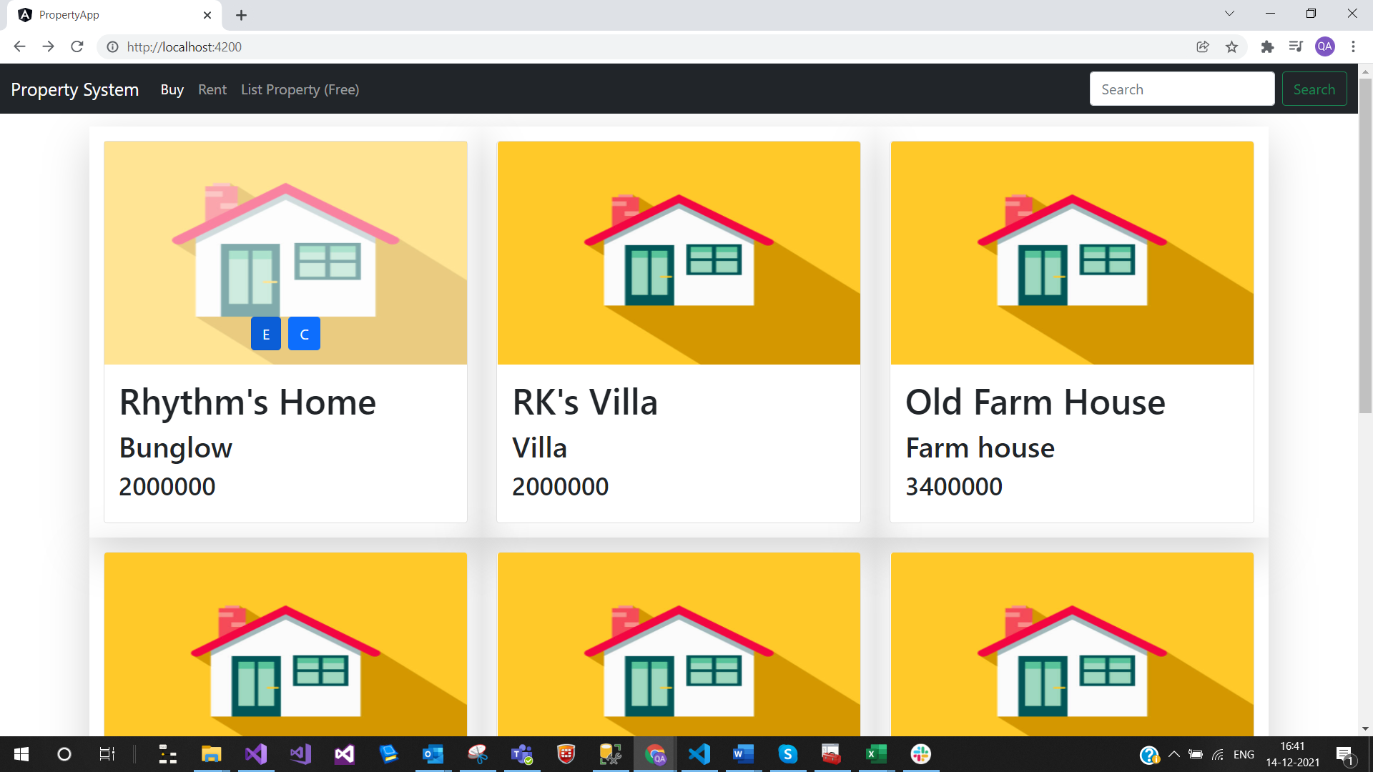

Clicking on E button should navigate to the property-details component as below

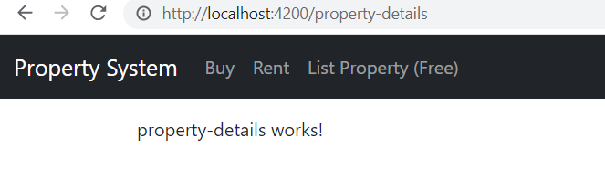

### How to pass the ID of the property to the property-details page

1. To pass any value along with the URL we need to change the format of the route like this

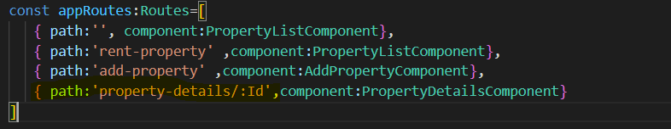

1. Change the routerLink association as below in the Property-card.component.html to pass the ID of the property

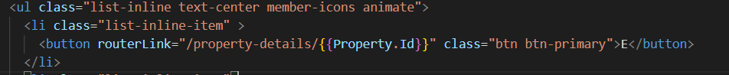

## How to fetch the parameter passed to the route in any component

To fetch the value of the parameter associated with the route in the component Angular provides the class called “ActivatedRoute”

To fetch the value use the below code in property-details-component

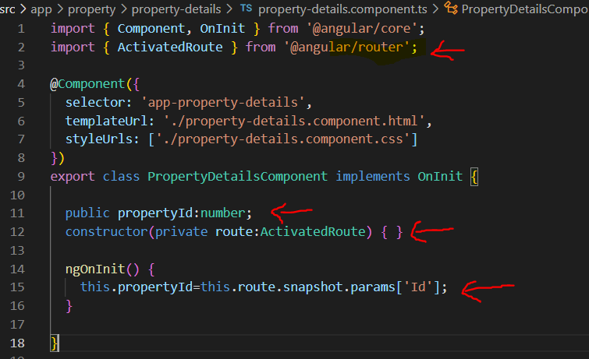

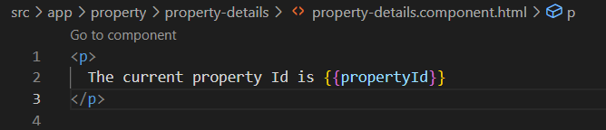

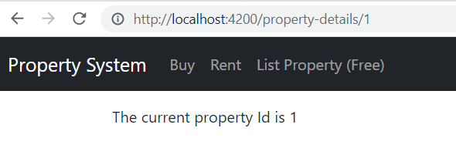

## How to use Router Service to achieve the navigation using event binding

1. Now let’s add a new button in the property add page where it will navigate back to the property listing page
2. We will use the Router Service provided by Angular to perform the navigation and associated the event binding in the button
3. Changes in add-property component will be like adding Router service in constructor, adding a function that needs to be bind with the button in html

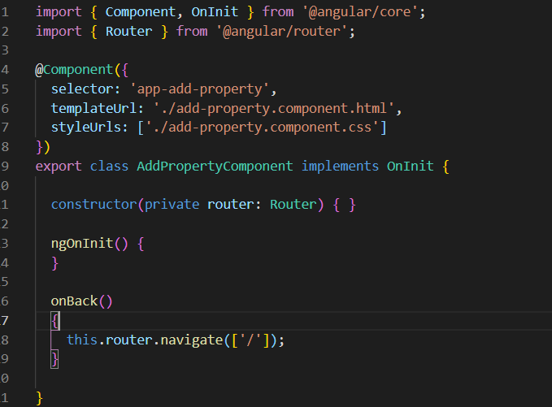

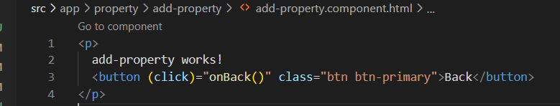

# Routing with Angular Part-3

In Earlier examples we looked how to navigate from one component to another and In this example we will understand how to perform the routing inside the same component.

## How to pass the value to the same component ?

1. We will add a new button in the property details html as below and bind a click event to it

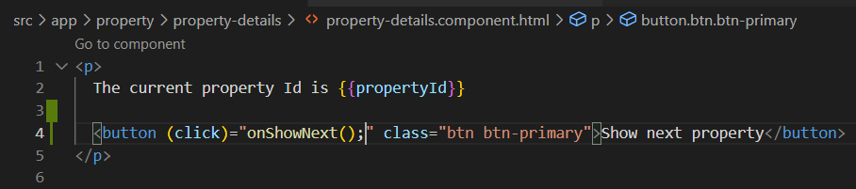

1. Add the Router service and create a new function onShowNext() which would use the Router service to navigate to the same component.

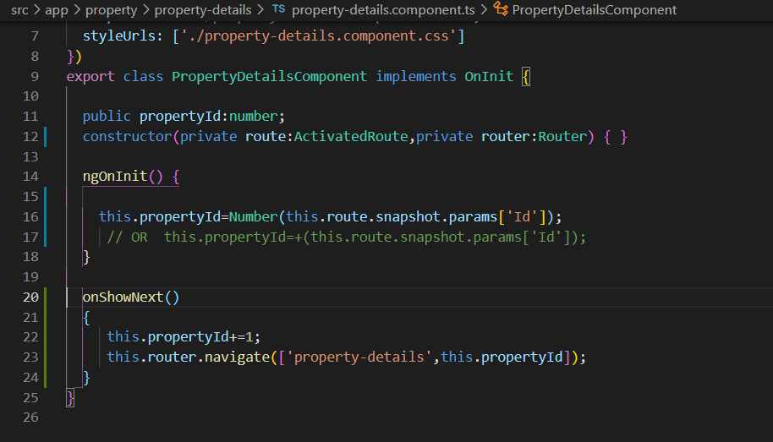

## How to navigate in the same component through RouterLink

1. In this scenario we will add some pagination like buttons which should allow us to navigate the route with values within the same component using RouterLink
2. So first add some buttons in the property details page like below

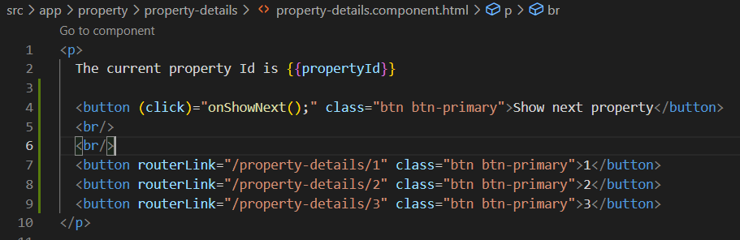

1. This approach will navigate within the component but will not associate the updates on the propertyId and for this we will need to subscribe the navigation to achieve the observable binding so add the below code to achieve this and reflect the route value in the component to bind the latest value

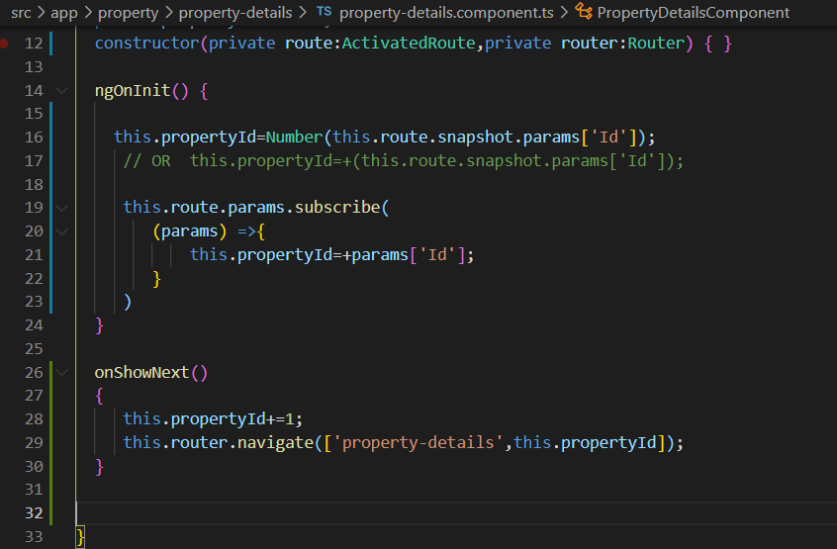

1. So adding the code from line 19 to 24 we will be able to navigate through buttons and bind the route values

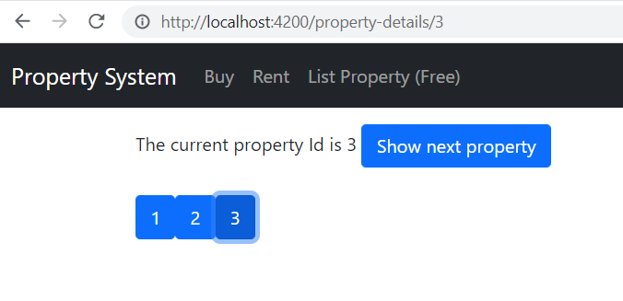

1. Another approach of binding the route with the RouterLink as shown below

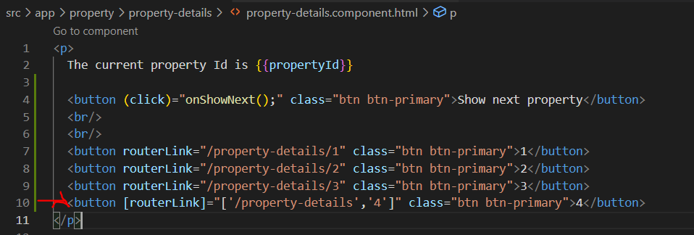

## How to render a page not found component

1. To achieve this we will need to define a path as below and navigate to any of the component which is related to it in the app.module.ts routes collectionShivbsb

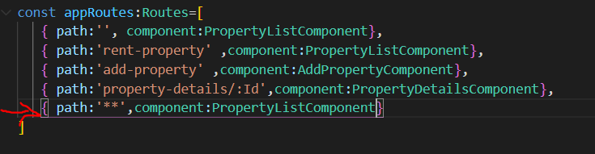

1. So when we will execute any of the URL that is not matching with the paths of the component we will render the property list component as below

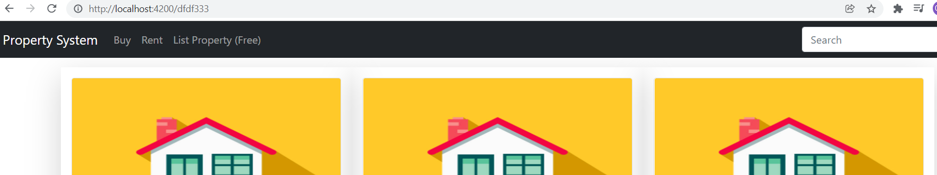

## How to render images of property from the model instead of hardcoded image

1. We need to bind the image paths dynamically to the card so download some other images and add a property in your properties.json file as well as In IProperty.Interface.ts interface as an optional type as below

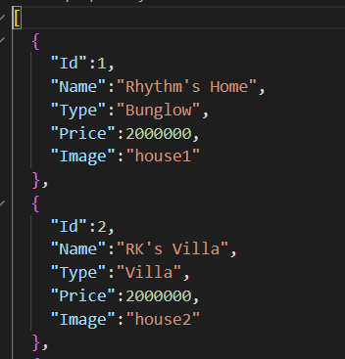

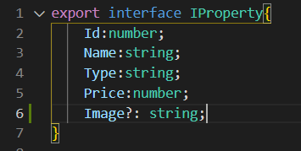

1. Now add the images to the assets folder and add the below *ngIf structural directives and bind the property image and also add the condition through *ngIf for binding the image if available and default if not in Property-card component html

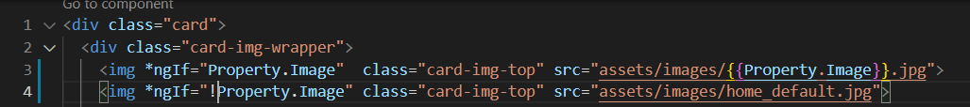

1. The output after the change would be like below

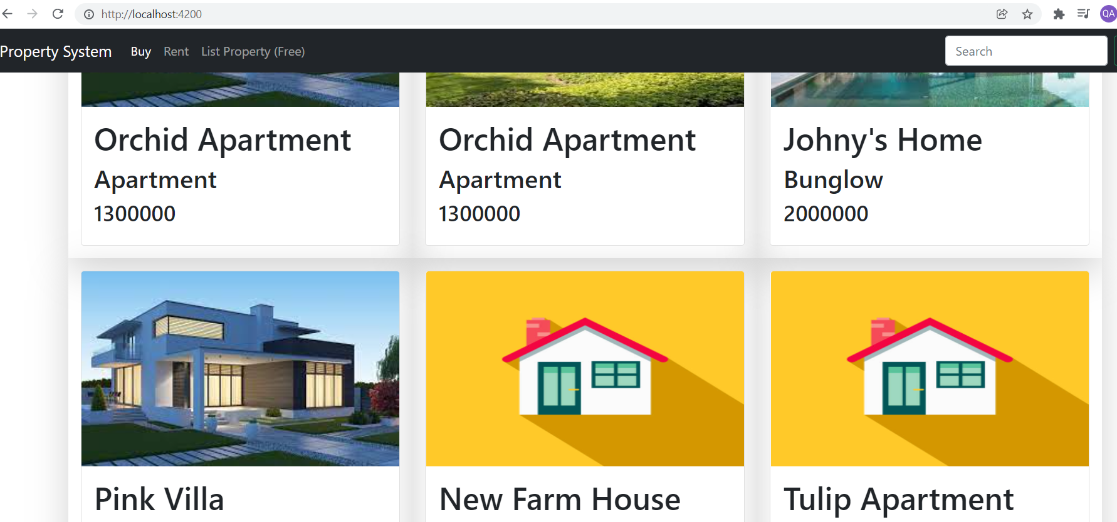

## Rendering the list of properties by passing a value of type sell or rent and map it to the Rent or Sell page

1. Add a new property in the property interface called “SellRent” as number

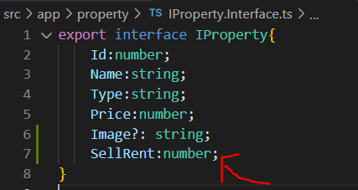

1. Add this property data in the properties.json

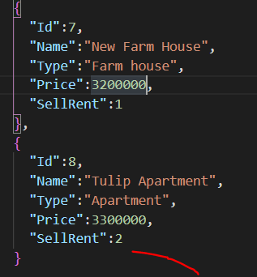

1. In properties list component declare the private variable of “SellRent” and default it to 1 which is sell

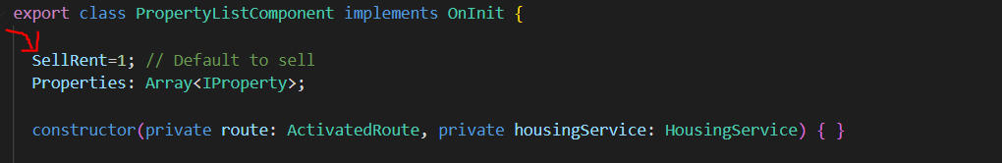

1. Add the ActivatedRoute service in the property details component constructor and check if the calling route url ha some url value in our case “rent-property” and if yes mark the SellRent value to 2

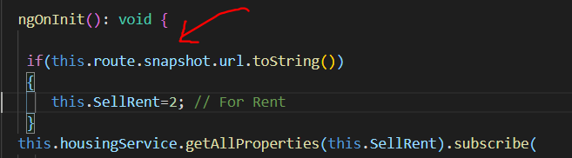

1. Pass this SellRent value to getAllProperties method of housing service

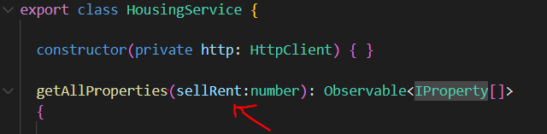

1. In housing service before pushing the data match the condition of SellRent passed to the method with the data coming from the json

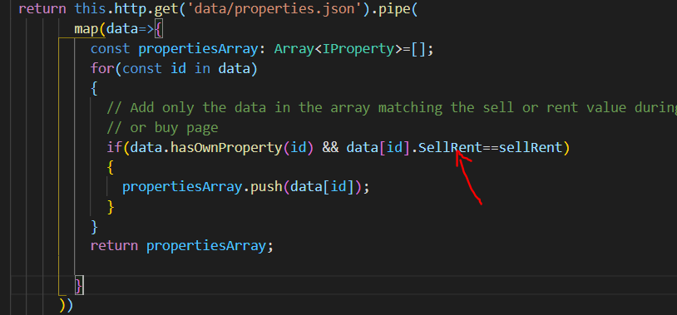

# Template Driven forms in Angular

1. Most of the logic is in the html template
2. Lets start adding the form inside the add-property.component.html as below

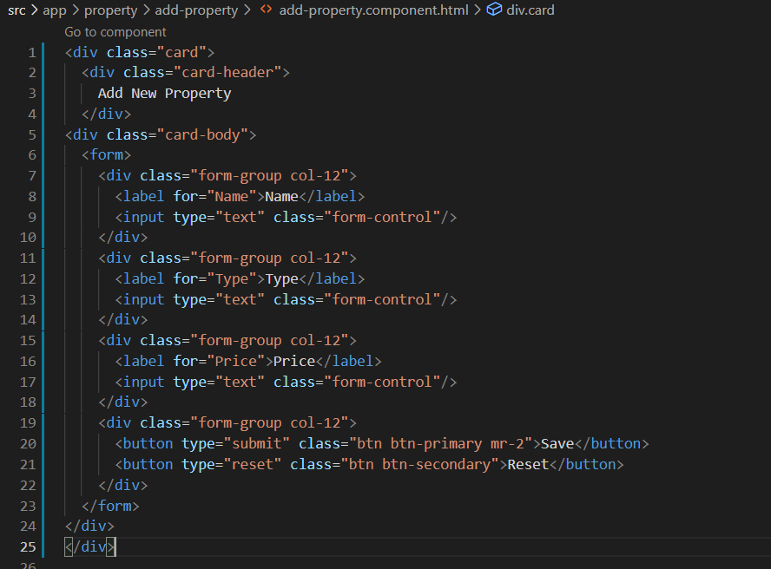

1. Import “FormsModule” in the app.module.ts and add it in the imports collection as below



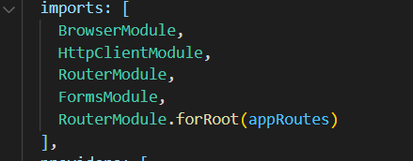

1. Bind the event in the form tag so that it starts posting the values to the component and a form name also provide the attributes to the form elements with “ngModel” and the name of the input control as below

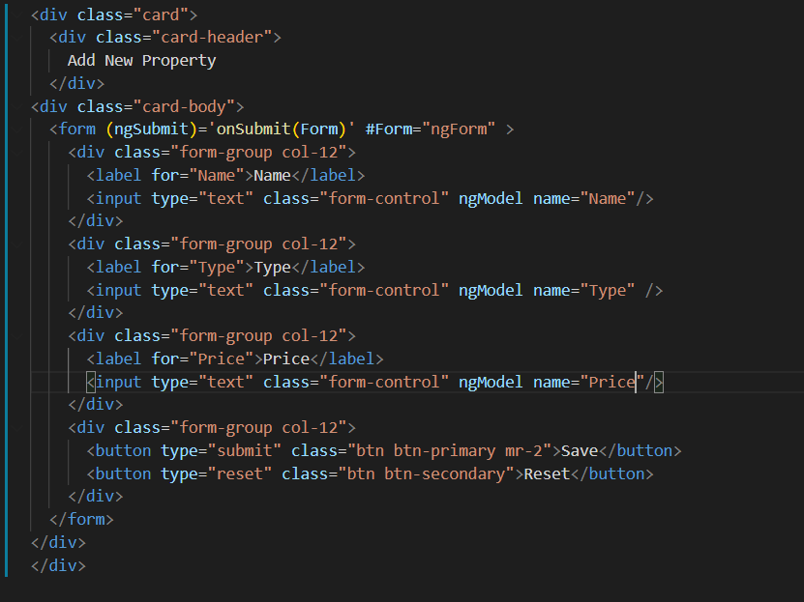

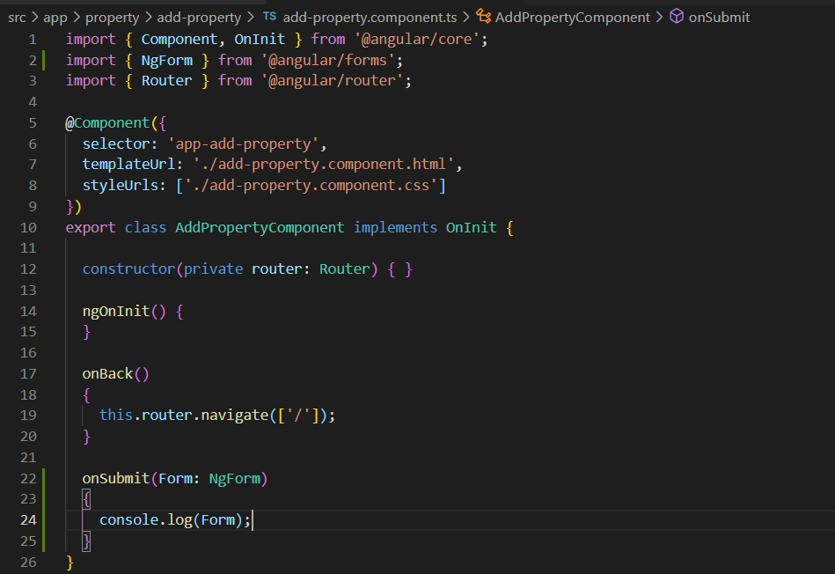

## Disable the save button by adding attribute

Add the required attribute In the controls

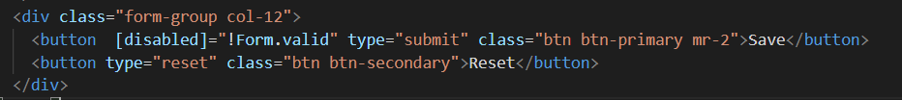

## Add the red border on textbox through Angular based classes

It will add border when the user has entered the cursor and then moved out of the control

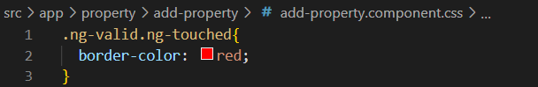

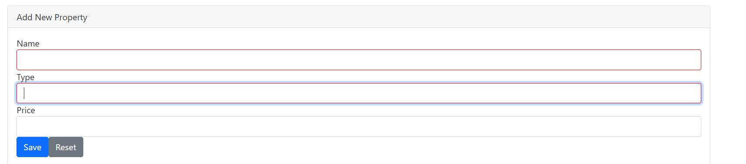

## How to show the warning message based on control valid state

1. Add a class , add the attribute in the control , add the span and check the condition with *ngIf directive as below

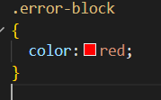

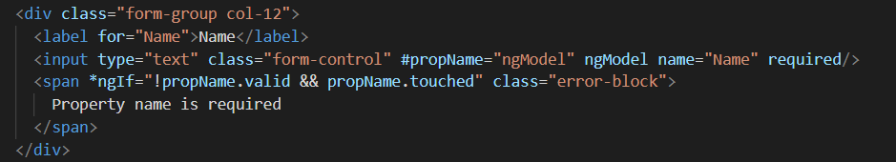

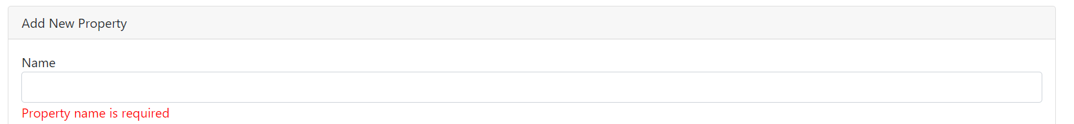

## How to get the reference of the ngForm in the component code

1. To get the reference of the ngForm in the component code do the below changes
2. Remove the passed parameter in the onSubmit method in html and in componet, Add the variable of type ViewChild as below

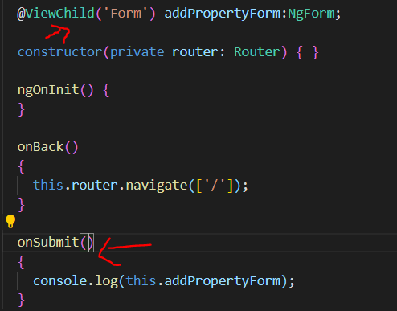



1. Use this section to add more validators for different scenarios of validations https://angular.io/api/forms/Validators

## Add the min-length validation along with other validations

1. We have added the required message validation message but we will now add one more validation for min length for a name field and display the specific error message
2. Do the below changes in your html

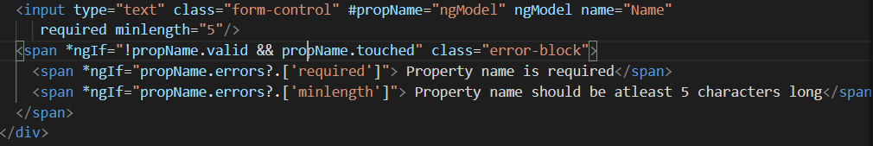

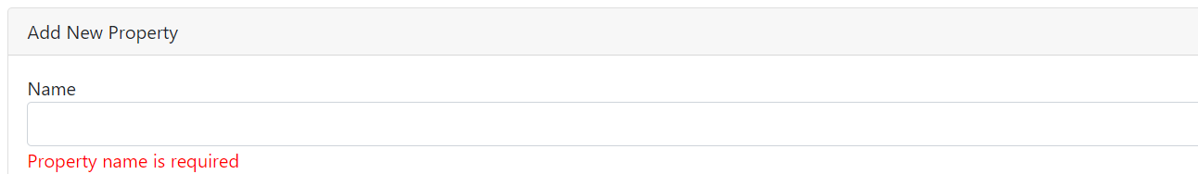

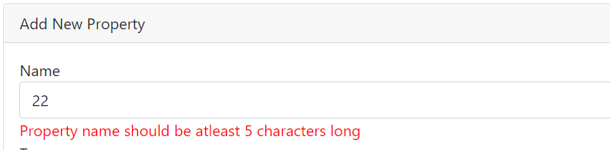

# Reactive Forms in Angular

1. We will create registration and login process using reactive forms
2. Add the nav items in the nav-bar as below in the right side where the search control is placed

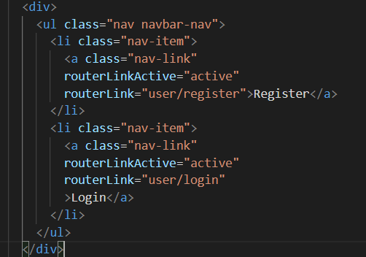

1. Add 2 new folders in app as below and add UserLogin and User Registration component respectively

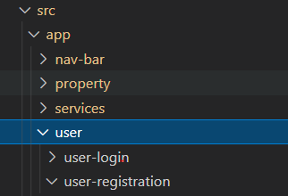

1. Also register these components in the app.module as below

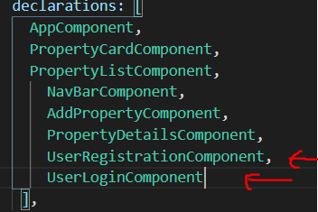

1. Now add the route paths for these new components as below

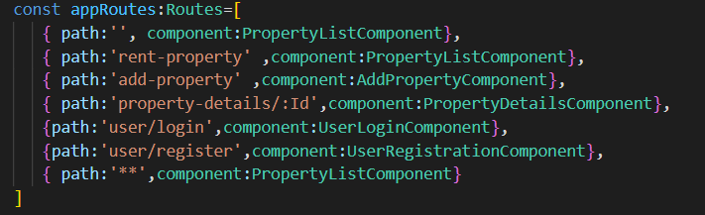

1. The module to work with the Reactive forms is “ReactiveFormsModule” so add it in the imports section in the app.module.ts

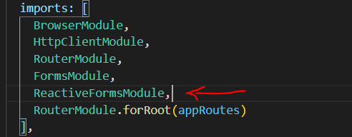

1. Now to build the reactive based forms we will use the FormGroup which
   1. Helps to fetch the form details in the component, track the state of the controls
   2. It’s a group of controls and validations for a specific form
   3. It’s a wrapper around the connected form controls
2. Also we will add the controls under this FormGroup as below with validations associated for each of the control

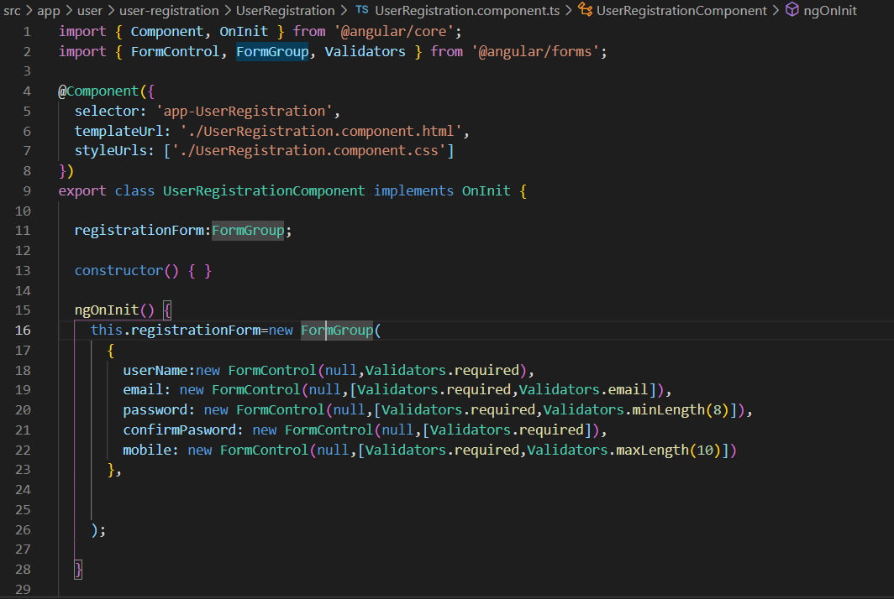

1. We will need to bind these form controls and validations with the html controls as below

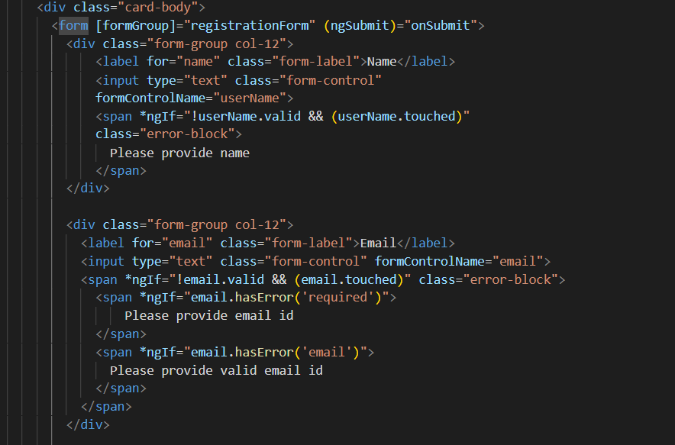

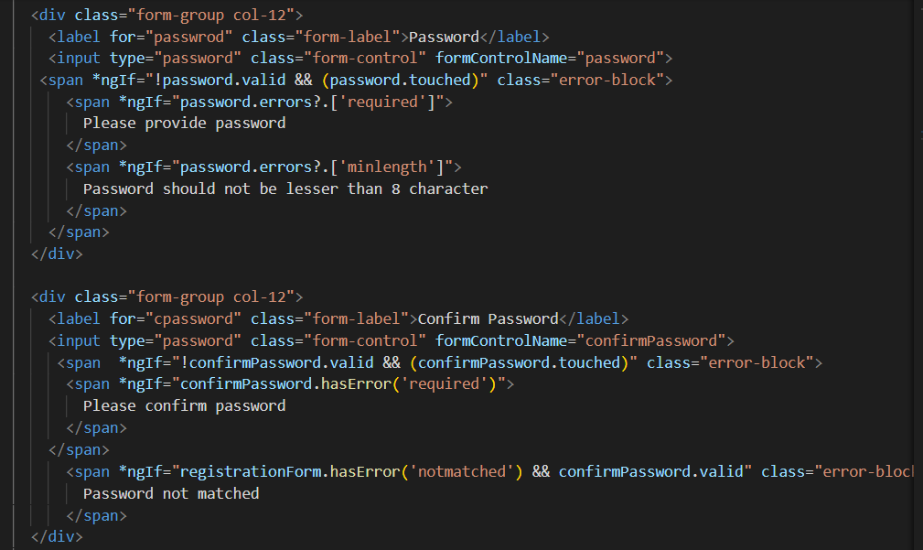

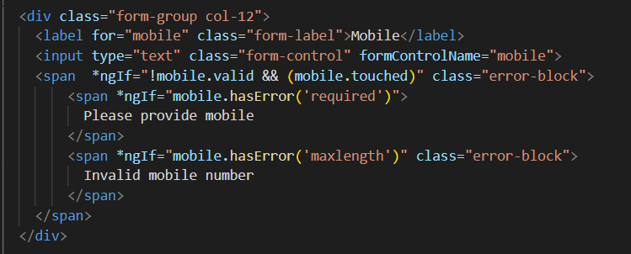

1. How to achieve cross-field validation e.g. Compare passwords for password and confirm password fields

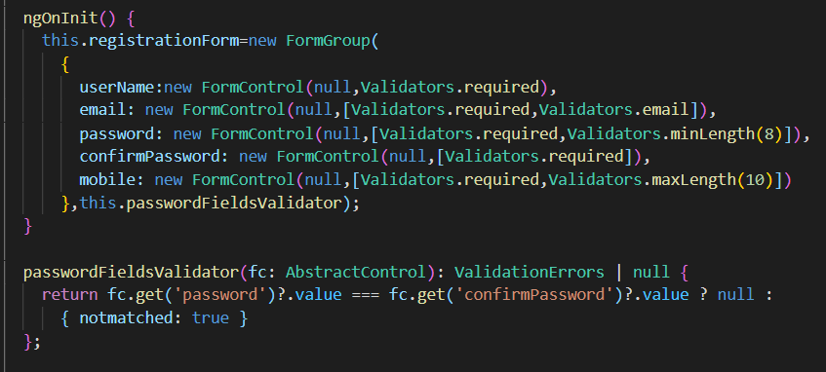

1. Adding getter method to expose any property value from typescript file and to use in the html form for more cleaner code

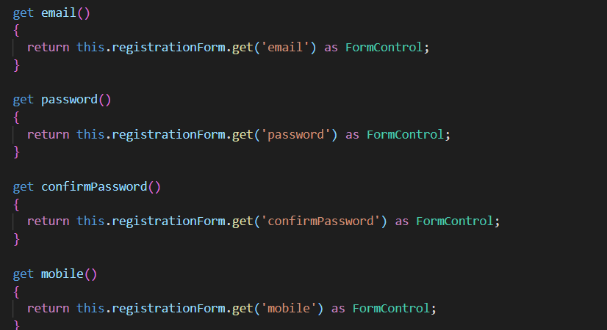

## How to add global level CSS

1. Add css in any respective folder here lets create forms.css in assets folder
2. Add @import ‘assets/forms.css’ in styles.css file

## Benefits of using reactive forms

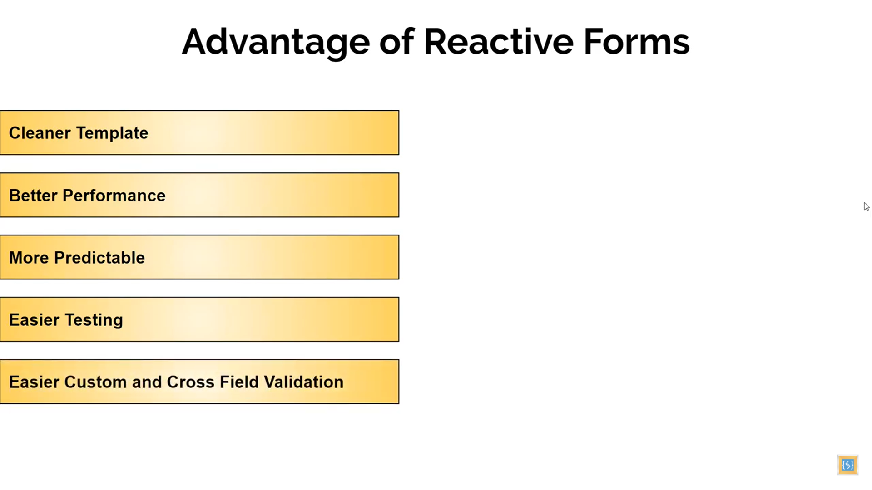

## Usage of FormBuilder

1. It’s a helper class to build the reactive forms
2. We can add all the controls under the FormBuilder which makes the code leaner and cleaner
3. Add FormBuilder service in the constructor

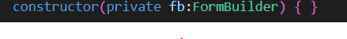

1. Add a new method called CreateRegistrationForm as below which will have all the form controls added in it

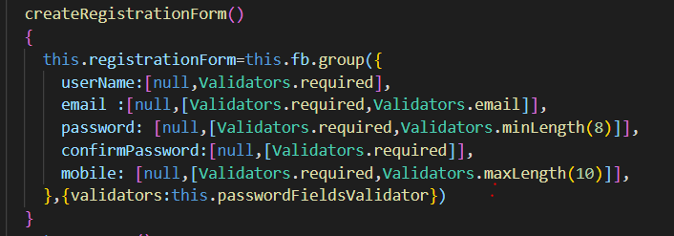

1. Comment out the code of FormGroup creation from the onInit method and call the CreateRegistrationForm as below

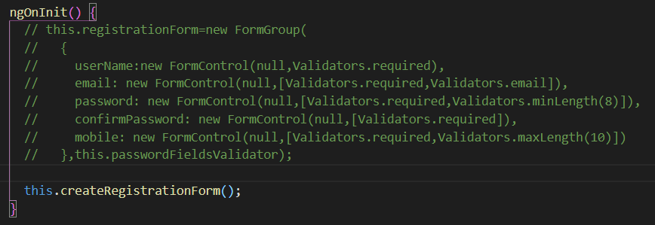

# Save data to local storage in Angular

1. On submit of the form we will add the user information in localstorage as below and keep on adding in an array

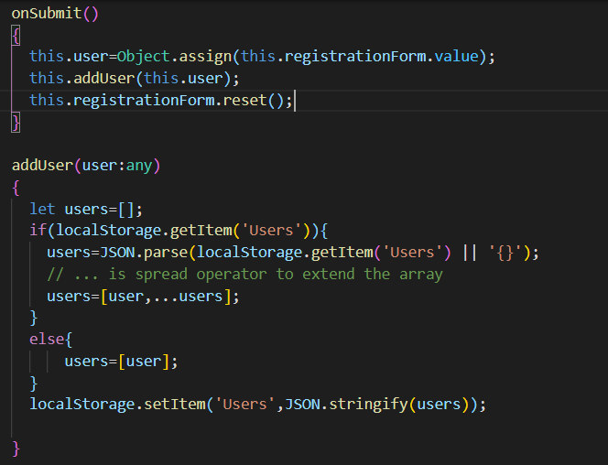

## Adding the user operations to a user service

1. Add a user service , add it to provider collection in the app.module.ts,move the add the adduser method in the user service and inject the userService to the constructor of registration component

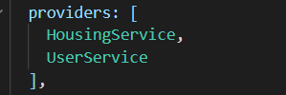

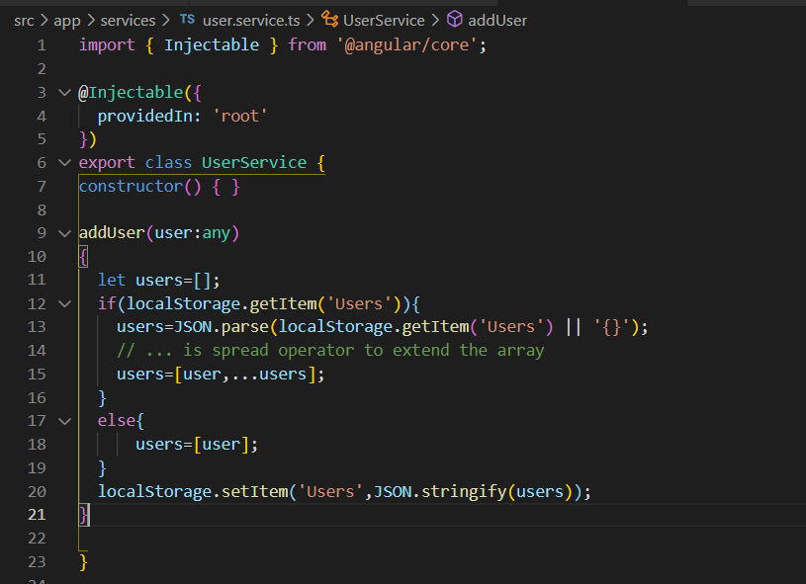

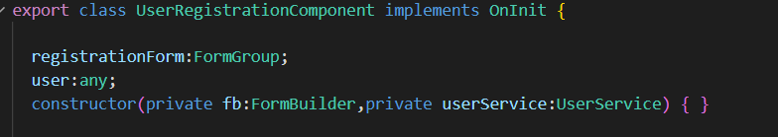

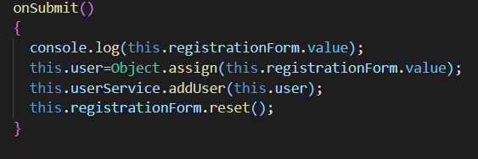

## Validating the form on Submit

1. On submit of the form the form valid status should be checked
2. Also the controls should be highlighted and validations should be fired
3. Add a flag in the registration form to handle whether the form was submitted
4. Add this flag in the condition where the validations spans are displayed

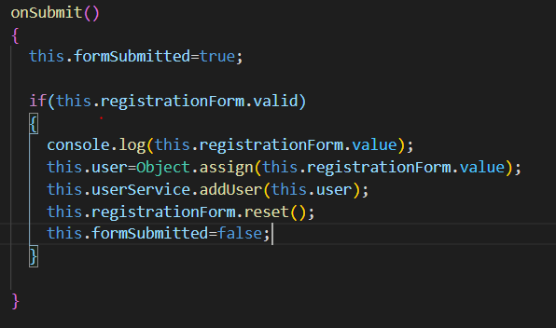

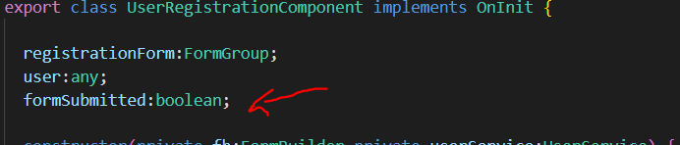

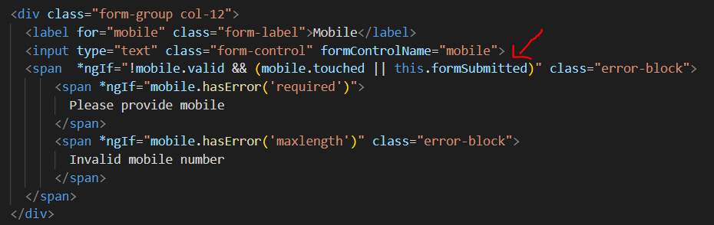

## Working with models

1. We should always work with specific domain object
2. So we should always add a domain model for this
   1. Add a model folder under app folder
   2. And add an interface called User in it as below

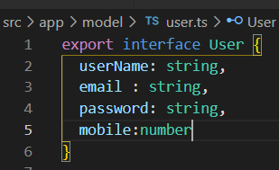

1. Create a new method in the user registration component for binding the control details to the user object and change the signature to pass the data to the user service and also change the data type in the addUser method to “User”

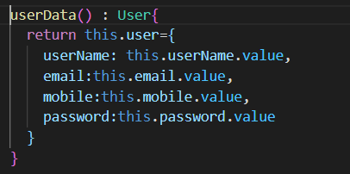

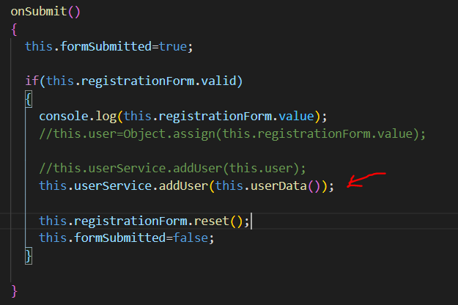

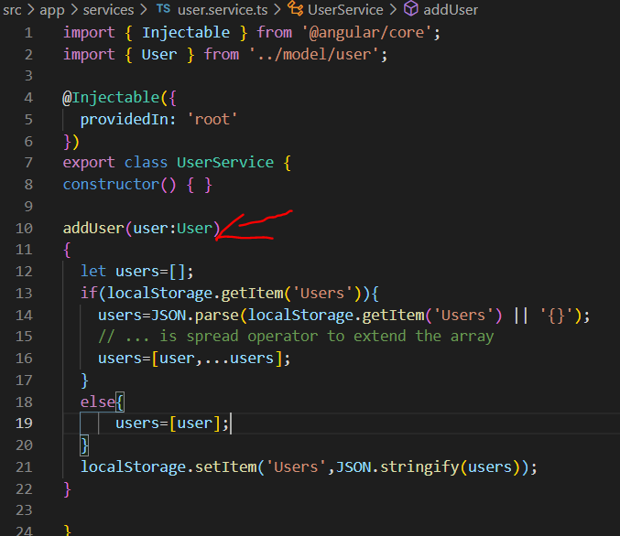

# Adding client-side alert notifications and dialogs

1. We will use Alertify.js for this implementation which is famous client side library
2. Open AlertifyJs.com and click on “View on Github”
3. There you would find the syntax of installing this package through NPM

npm install alertifyjs --save

1. Run this command from terminal from the root of your project and check the installed package in node_modules



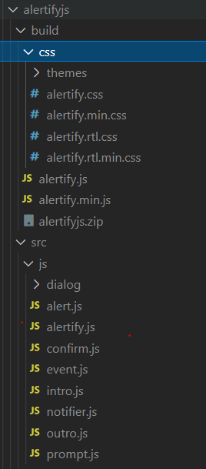

1. To add this alertify css package available globally we will need to import these in style.css file as below

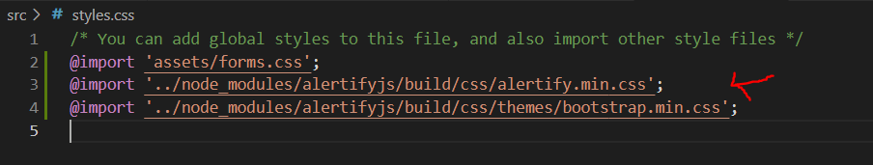

1. To access the functions of client side library we will need to import it in the component we require. Here we need it in the Registration component so add it as below



But this gives a warning that there should be d.ts file for this to add the import so

1. Add a new d.ts file in the src folder named alertifytype.d.ts and add this import over there

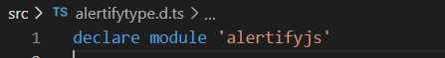

1. Also add the new path in typeRoots in tsconfig.json as below

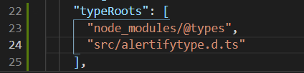

1. To consume this alertify library first add this import in registration component



1. And we will alert the user for success and error message during performing registration

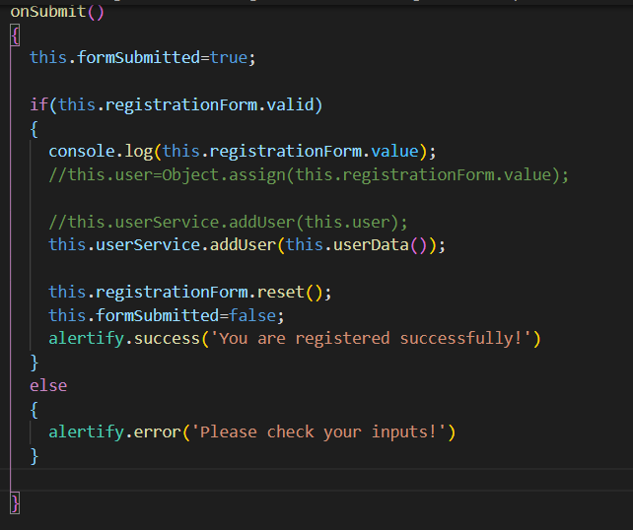

1. But as we need to use this alertify feature in many other components too we should wrap that to a service
   1. Add a new service called Alertify
   2. Add the new service methods and code meant for alertify

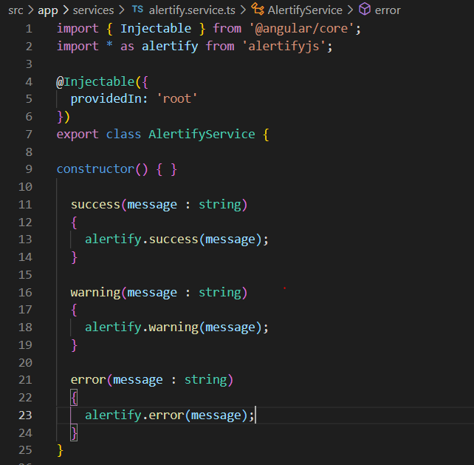

1. Add this service in appmodule providers section

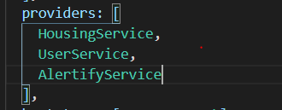

1. Inject this alertify service inside the registration component



# Login / Logout features hands-on

1. In this hands-on we will implement login, logout features for our app.
2. The token would be stored in the localstorage
3. Login screen HTML which would be a template-based form

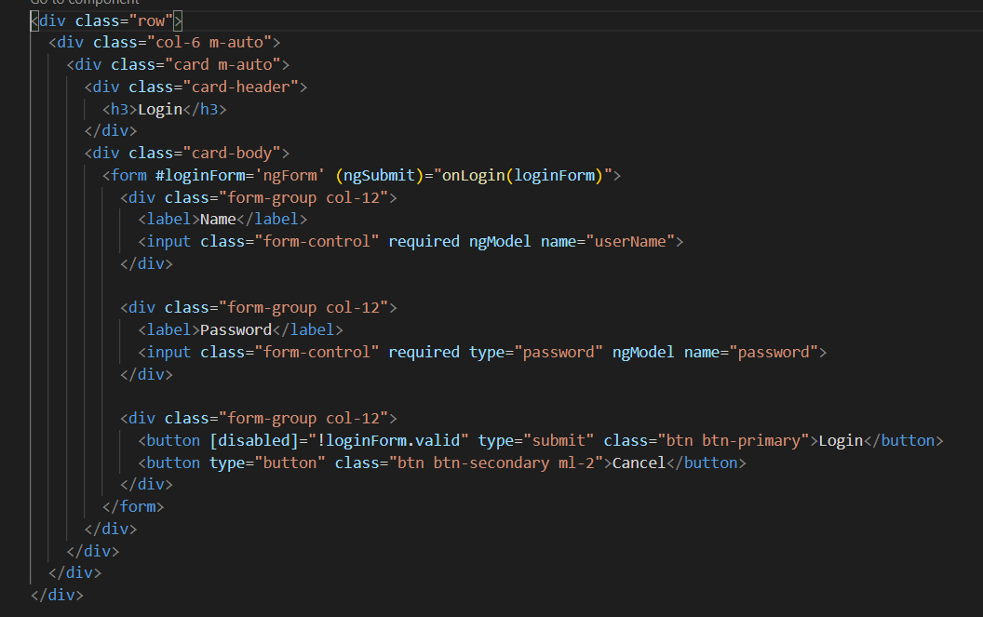

1. The login component looks like this

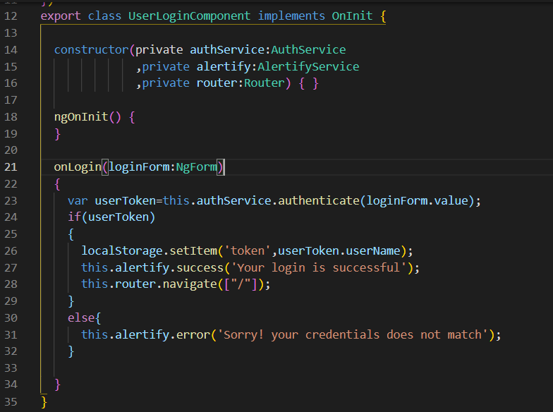

1. The auth service would look like this

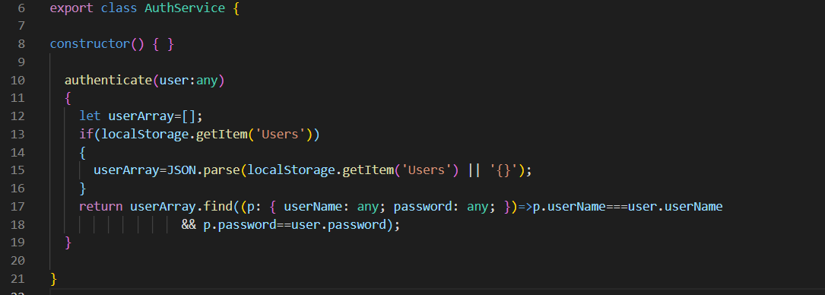

1. Update the nav bar HTML where we have added login, logout and register controls in html and its component details are as below

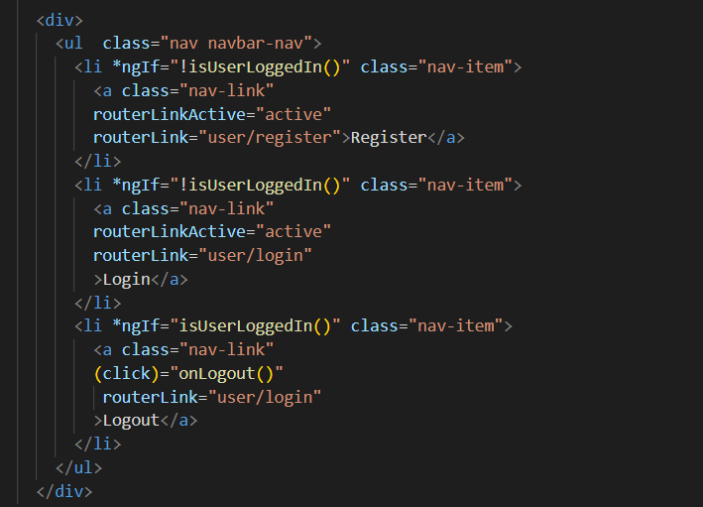

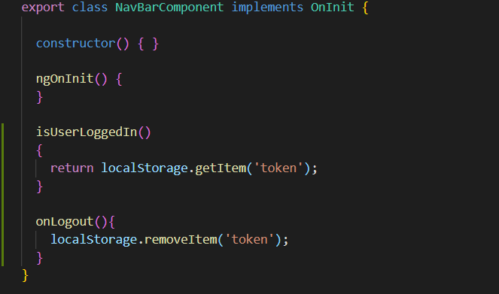

## Adding more menus to the home screen in nav bar

1. We will use ngx-bootstrap which contains angular compatible bootstrap controls
2. To install this library run this angular command in your terminal

**npm install ngx-bootstrap –save**

1. Next we will use specific dropdowns component from ngx-bootstrap library as below

**ng add ngx-bootstrap –component dropdowns**

1. The above command will add below imports in app.module.ts

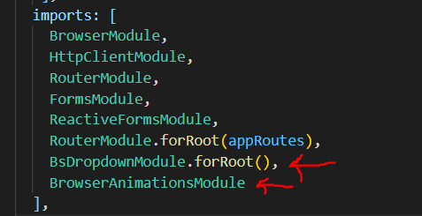

1. Update the nav-bar html to render the dropdown with additional menus after user is logged in

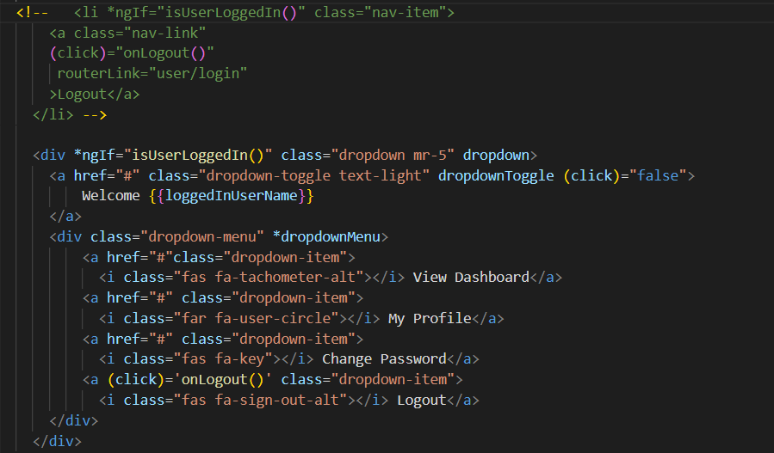

1. Add the property in the nav component to assign the logged in user to a property which is shown in {{loggedInUserName}}

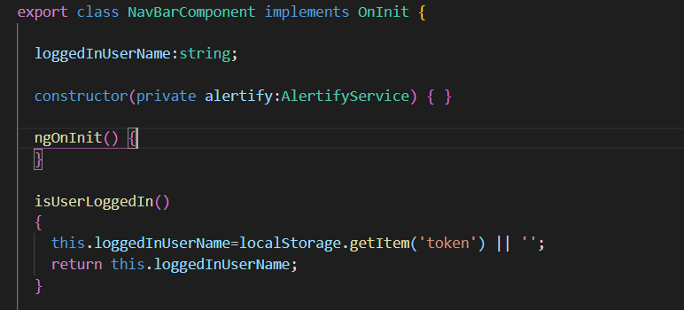

# Add new property listing – Hands ON